**Captive Portal Art Machine:**

**the importance of accessible technology for artistic use.**

*Author:*

[Alex Leitch](http://www.alexleitch.com/)

*Supervisor:*

[Dr. Emma Westecott](https://twitter.com/emmawestecott)

*A thesis submitted in partial fulfilment of the requirements for the degree of Master of Design*

*in Digital Futures*

*in the Faculty of Design of OCAD University*

*April 10, 2014*



This work is licensed under a Creative Commons

Attribution-ShareAlike 4.0 International License.

*Declaration of Authorship*

I, Alex Leitch, declare that this thesis titled, ’Captive Portal Art Machine:

the importance of accessible technology for artistic use.’ and the work presented in it are my own. I confirm that:

• This work was done wholly or mainly while in candidature for a master’s degree at this

University.

• Where any part of this thesis has previously been submitted for a degree or any other qualification at this University or any other institution, this has been clearly stated.

• Where I have consulted the published work of others, this is always clearly attributed.

• Where I have quoted from the work of others, the source is always given. With the exception of such quotations, this thesis is entirely my own work.

• I have acknowledged all main sources of help.

• Where the thesis is based on work done by myself jointly with others, I have made clear exactly what was done by others and what I have contributed myself.

Signed:

Date:

*Abstract*

[Ontario College of Art and Design University](http://www.ocadu.ca/)

Master of Design

Digital Futures

**Captive Portal Art Machine:**

**the importance of accessible technology for artistic use.**

by Alex Leitch

13th March 2014

This thesis consists of technical design project to, on one hand, make it easier for video artists to assemble web-based dual-screen branched narratives, and then to install and display them consistently in environments without consistent access to the internet. The project examines what it means for technology to be accessible, and how that accessible technology is commodified in support of the arts.

The installation of works based on the technology took place during a two-year period between

2013 and 2014 in a variety of exhibition contexts. This essay consists of technical details of installation as well as conceptual supports for what accessibility means, from a feminist and game-art perspective.

*Acknowledgements*

I wish to express my appreciation of my thesis advisors, Emma Westecott and Simone Jones, without whose generous contribution of time and sensible advice this would be a much weaker paper. I would also like to express gratitude to the Site 3 coLaboratory community, who provided me space to work and a community to work with, and Bento Miso - Dann Toliver, Cecily Carver, Jennie and Henry Faber expressly - for their technical advice and their help in hosting No Jam 2. I would also like to extend my thanks to Evan of the Digital Futures tech desk for a key tip when I was just starting my research. Hannah Epstein deserves my thanks as well for being a fantastic collaborator.

To my personal support community, many thanks for your patience with me for the duration of this work.

*For Adina. . .*

TABLE OF CONTENTS

**Declaration of Authorship ii**

**Abstract iii**

**Acknowledgements iv**

**List of Figures ix**

**Abbreviations x**

**1 Introduction: A Better Time-Based Installation 1**

1.1 Introduction . . . . . . . . . . . . . . . . . . . . . . . . . . . . . . . . . . . . . . . 1

1.2 Designing Software to Power Experience . . . . . . . . . . . . . . . . . . . . . . . 2

1.3 Interaction and Presentation in Game Design . . . . . . . . . . . . . . . . . . . . 5

1.4 Initial Approach . . . . . . . . . . . . . . . . . . . . . . . . . . . . . . . . . . . . 11

1.4.1 Federal Development Grant, game:play Lab, and collaborative artistic practices . . . . . . . . . . . . . . . . . . . . . . . . . . . . . . . . . . . . . 11

1.4.2 Code and Theory . . . . . . . . . . . . . . . . . . . . . . . . . . . . . . . . 13

1.4.3 Game Design Research . . . . . . . . . . . . . . . . . . . . . . . . . . . . . 15

1.4.4 Feminism, Cybernetics, and System Controls . . . . . . . . . . . . . . . . 17

**2 Background, Theory, and the State of the Art 19**

2.1 Game Engines . . . . . . . . . . . . . . . . . . . . . . . . . . . . . . . . . . . . . . 19

2.1.1 Twine . . . . . . . . . . . . . . . . . . . . . . . . . . . . . . . . . . . . . . 20

2.1.2 Multiscreen Video Technology . . . . . . . . . . . . . . . . . . . . . . . . . 21

2.2 Theory and Politics . . . . . . . . . . . . . . . . . . . . . . . . . . . . . . . . . . . 21

**3 Software Design, Industry Engagement, and Hardware Design 24**

|  |  |  |  |  |  |  |  |  |  |  |  |  |  |  |  |  |  |  |  |  |
| --- | --- | --- | --- | --- | --- | --- | --- | --- | --- | --- | --- | --- | --- | --- | --- | --- | --- | --- | --- | --- |
| 3.1 Software Design . . . . . . . . . . . . . . . . . . | . | . | . | . | . | . | . | . | . | . | . | . | . | . | . | . | . | . | . | 24 |
| 3.1.1 screenPerfect Engine—Interface Layout | . | . | . | . | . | . | . | . | . | . | . | . | . | . | . | . | . | . | . | 26 |
| 3.2 Design Research . . . . . . . . . . . . . . . . . | . | . | . | . | . | . | . | . | . | . | . | . | . | . | . | . | . | . | . | 28 |

|  |  |  |  |  |  |  |  |  |  |  |  |  |  |  |  |  |  |  |  |  |  |  |  |  |  |  |  |  |  |  |  |
| --- | --- | --- | --- | --- | --- | --- | --- | --- | --- | --- | --- | --- | --- | --- | --- | --- | --- | --- | --- | --- | --- | --- | --- | --- | --- | --- | --- | --- | --- | --- | --- |
| 3.2.1 Artist Collaboration . . . . . . . . . . . . . | | | | | | | | | | | | | | . | . | . | . | . | . | . | . | . | . | . | . | . | . | . | . | . | 28 |
| 3.3 Development Methods . . . . . . . . . . . . . . . . | | | | | | | | | | | | | | . | . | . | . | . | . | . | . | . | . | . | . | . | . | . | . | . | 28 |
| 3.3.1 Agile Development with an Artist Partner | | | | | | | | | | | | | | . | . | . | . | . | . | . | . | . | . | . | . | . | . | . | . | . | 28 |
| 3.3.2 | GitHub and Open Source Software | | | | | | | | . | . | . | . | . | . | . | . | . | . | . | . | . | . | . | . | . | . | . | . | . | . | 31 |
| 3.3.3 | Licencing . . . . . . . | . | . | . | . | . | . | . | . | . | . | . | . | . | . | . | . | . | . | . | . | . | . | . | . | . | . | . | . | . | 32 |
| 3.3.4 | Science Fiction Inputs | . | . | . | . | . | . | . | . | . | . | . | . | . | . | . | . | . | . | . | . | . | . | . | . | . | . | . | . | . | 32 |
| 3.4 Industry Engagement . . . . . . . . . . . . . . . . . . . . . . . . . . . . . . . . . 33 | | | | | | | | | | | | | | | | | | | | | | | | | | | | | | | |
| 3.4.1 | Game Jams, A Design Method | | | | | | . | . | . | . | . | . | . | . | . | . | . | . | . | . | . | . | . | . | . | . | . | . | . | . | 33 |
| 3.4.2 | Dames Making Games and Game Jams | | | | | | | | | | | . | . | . | . | . | . | . | . | . | . | . | . | . | . | . | . | . | . | . | 34 |
| 3.4.3 | Bento Miso and Bento Box . . . . . . . | | | | | | | | | | | . | . | . | . | . | . | . | . | . | . | . | . | . | . | . | . | . | . | . | 35 |
| 3.4.4 | NoJam 2: Video Video . . . . . . . . . . | | | | | | | | | | | . | . | . | . | . | . | . | . | . | . | . | . | . | . | . | . | . | . | . | 36 |

**4 Hardware Deployment in Limited Local Space 39**

4.1 Public Installations . . . . . . . . . . . . . . . . . . . . . . . . . . . . . . . . . . . 40

4.2 Hardware Design . . . . . . . . . . . . . . . . . . . . . . . . . . . . . . . . . . . . 42

4.3 Physical Deployment on the Raspberry Pi . . . . . . . . . . . . . . . . . . . . . . 45

4.3.1 Problems and Complications in Display . . . . . . . . . . . . . . . . . . . 47

4.3.2 Subnod.es and Public Private Space . . . . . . . . . . . . . . . . . . . . . 48

4.3.3 Materials and Supplies . . . . . . . . . . . . . . . . . . . . . . . . . . . . . 49

4.4 Background for Linux Commands . . . . . . . . . . . . . . . . . . . . . . . . . . . 50

4.5 Setting Up The Raspberry Pi . . . . . . . . . . . . . . . . . . . . . . . . . . . . . 50

4.5.1 Windows 7 SD Card setup and first boot . . . . . . . . . . . . . . . . . . 50

4.5.2 Configuring Raspbian . . . . . . . . . . . . . . . . . . . . . . . . . . . . . 51

4.6 Software Setup for External WiFi Access . . . . . . . . . . . . . . . . . . . . . . 52

4.7 Installing Node.JS . . . . . . . . . . . . . . . . . . . . . . . . . . . . . . . . . . . 55

4.7.1 Why Node? . . . . . . . . . . . . . . . . . . . . . . . . . . . . . . . . . . . 55

4.7.2 Installation Instructions for Node.JS . . . . . . . . . . . . . . . . . . . . . 56

4.8 Testing Node . . . . . . . . . . . . . . . . . . . . . . . . . . . . . . . . . . . . . . 57

4.8.1 Selecting Monitoring Software . . . . . . . . . . . . . . . . . . . . . . . . . 57

4.8.2 Installation of Node Modules . . . . . . . . . . . . . . . . . . . . . . . . . 58

4.8.3 Troubleshooting NPM installations . . . . . . . . . . . . . . . . . . . . . . 58

4.9 SSH via Direct Ethernet Connection

and WiFi Internet Access . . . . . . . . . . . . . . . . . . . . . . . . . . . . . . . 59

4.10 Backing Up the Raspberry Pi . . . . . . . . . . . . . . . . . . . . . . . . . . . . . 61

4.11 Mount Your USB Flash Memory Stick To the Raspberry Pi . . . . . . . . . . . . 61

|  |  |  |  |  |  |  |  |  |  |  |  |  |  |  |  |  |  |  |  |  |  |  |
| --- | --- | --- | --- | --- | --- | --- | --- | --- | --- | --- | --- | --- | --- | --- | --- | --- | --- | --- | --- | --- | --- | --- |
|  | 4.11.1 Configuring Your Mount Drive . . . . | . | . | . | . | . | . | . | . | . | . | . | . | . | . | . | . | . | . | . | . | 61 |
| 4.11.2 How to Boot Mount External Memory | . | . | . | . | . | . | . | . | . | . | . | . | . | . | . | . | . | . | . | . | 62 |
| 4.12 | Set Up a wiFi Hotspot . . . . . . . . . . . . . | . | . | . | . | . | . | . | . | . | . | . | . | . | . | . | . | . | . | . | . | 63 |
| 4.13 | Configuring HostAPD . . . . . . . . . . . . . | . | . | . | . | . | . | . | . | . | . | . | . | . | . | . | . | . | . | . | . | 64 |

4.14 Configuring DNS access via dnsmasq . . . . . . . . . . . . . . . . . . . . . . . . . 66

**5 Conclusion 67**

5.1 Conclusion . . . . . . . . . . . . . . . . . . . . . . . . . . . . . . . . . . . . . . . 67

**A screenPerfect Installation Guide 71**

A.1 screenPerfect Code and Documentation . . . . . . . . . . . . . . . . . . . . . . . 71

A.2 Device List . . . . . . . . . . . . . . . . . . . . . . . . . . . . . . . . . . . . . . . 71

A.3 Software List . . . . . . . . . . . . . . . . . . . . . . . . . . . . . . . . . . . . . . 72

A.4 Installation and Site Construction . . . . . . . . . . . . . . . . . . . . . . . . . . 72

A.4.1 Before Leaving For Site . . . . . . . . . . . . . . . . . . . . . . . . . . . . 72

A.5 Troubleshooting . . . . . . . . . . . . . . . . . . . . . . . . . . . . . . . . . . . . . 73

A.5.1 On Start, Google Chrome Cannot Find Control Screen . . . . . . . . . . . 73

A.5.2 The Control Device is frozen, or the videos are not changing. . . . . . . . 73

|  |  |  |  |  |  |  |  |  |  |  |  |  |  |  |  |  |  |  |  |  |  |  |  |  |  |  |  |  |  |  |  |
| --- | --- | --- | --- | --- | --- | --- | --- | --- | --- | --- | --- | --- | --- | --- | --- | --- | --- | --- | --- | --- | --- | --- | --- | --- | --- | --- | --- | --- | --- | --- | --- |
| A.6 | Tidbits and Tech Notes . . . | . | . | . | . | . | . | . | . | . | . | . | . | . | . | . | . | . | . | . | . | . | . | . | . | . | . | . | . | . | 74 |

**B Annotated Literature Review 75**

B.1 Literature Review . . . . . . . . . . . . . . . . . . . . . . . . . . . . . . . . . . . 75

**C Game Jam Documentation 81**

C.1 Interview Files . . . . . . . . . . . . . . . . . . . . . . . . . . . . . . . . . . . . . 81

C.2 Questions To Ask Game Jammers . . . . . . . . . . . . . . . . . . . . . . . . . . 81

C.2.1 Games List . . . . . . . . . . . . . . . . . . . . . . . . . . . . . . . . . . . 81

C.2.2 Bug Discovery . . . . . . . . . . . . . . . . . . . . . . . . . . . . . . . . . 82

C.2.3 Features Requested by Game Jammers . . . . . . . . . . . . . . . . . . . . 82

C.2.4 Notes from committed jammers about screenPerfect . . . . . . . . . . . . 82

**D Appendix D: MIT Licence and Research Ethics Approval 83**

D.1 MIT Licence . . . . . . . . . . . . . . . . . . . . . . . . . . . . . . . . . . . . . . 83

**Bibliography 86**

LIST OF FIGURES

|  |  |  |  |  |  |  |  |
| --- | --- | --- | --- | --- | --- | --- | --- |
| 1.1 | SNES Game Cartridge, 1995 . . . . . . . . . . . . . . . . . . . . . . . . | . | . | . | . | . | 12 |
| 1.2 | Seizuredome, S. Kochavi, A. Shulz, 2013. A tent with video installation. | . | . | . | . | . | 13 |

|  |  |  |  |  |  |  |  |  |  |  |  |  |  |  |  |  |  |  |  |
| --- | --- | --- | --- | --- | --- | --- | --- | --- | --- | --- | --- | --- | --- | --- | --- | --- | --- | --- | --- |
| 3.1 | screenPerfect software communication model . . . | . | . | . | . | . | . | . | . | . | . | . | . | . | . | . | . | . | 25 |
| 3.2 | screenPerfect NoJam editor, Asset Population tab. | . | . | . | . | . | . | . | . | . | . | . | . | . | . | . | . | . | 27 |
| 3.3 | screenPerfect NoJam editor, Exit Population tab. . | . | . | . | . | . | . | . | . | . | . | . | . | . | . | . | . | . | 27 |
| 4.1 | Hannah Epstein psXXYborg at VideoFag, 1995 . . | . | . | . | . | . | . | . | . | . | . | . | . | . | . | . | . | . | 39 |
| 4.2 Hannah Epstein, Alex Leitch, Sagan Yee psXXYborg at VideoFag, 1995 . . . . . 40 | | | | | | | | | | | | | | | | | | | |
| 4.3 | Alex Leitch Concept for collapsible projection space 2013 | | | | | . | . | . | . | . | . | . | . | . | . | . | . | . | 41 |
| 4.4 | Alex Leitch Concept for portable arcade box, 2013 . . . . | | | | | . | . | . | . | . | . | . | . | . | . | . | . | . | 42 |
| 4.5 | Abe Shulz and Sage Kochavi Seizuredome at FireFly 2013 | | | | | . | . | . | . | . | . | . | . | . | . | . | . | . | 46 |
| 4.6 | Raspberry Pi with functioning wiFi antenna . . . . . . . . | | | | | . | . | . | . | . | . | . | . | . | . | . | . | . | 54 |
| 4.7 | Raspberry Pi in Thingiverse case . . . . . . . . . . . . . . | | | | | . | . | . | . | . | . | . | . | . | . | . | . | . | 54 |

*Abbreviations*

**CYOA C**hoose **Y**our **O**wn **A**dventure

A popular format for game narrative, describing a branched, choice-based structure, as versus a linear story.

**FiG F**eminists **i**n **G**ames

A SSHRC-funded association of digital researchers interested in disrupting gender bias in game development.

**DMG D**ames **M**aking **G**ames

A non-profit community organization based in Toronto dedicated to supporting dames interested in making, playing, and

changing games.

**JS J**ava**S**cript

A scripting language, traditionally used for client-side programming on the web.

**Indie I**ndependent Developer

Indie developers are game developers not associated with tradtional, well-funded development houses.

CHAPTER

**ONE**

INTRODUCTION: A BETTER TIME-BASED INSTALLATION

**1.1 Introduction**

What constitutes good design? As described by Don Norman in the book ”The Design of Every- day Things,” (Norman, 2002) design can be sympathetic to their users, or have psychopathy coded directly into the construction of design artefacts. ScreenPerfect has been designed to address the question of how we might improve software based on internet technologies to be more useful to artists.

This project has several parts which will be explained separately. The first part of the project is an application to build branched narratives out of video files, coded in javascript on the Node.JS framework for distribution via common internet technologies. This portion of the research has to do with the idea of resistance and how human abilities can be expanded by using contemporary technology, which is made by trained technicians but then released to be used without a proscriptive definition of the use case. Users make use of the engine, developed through one specific user’s design practice, to design new things. The first section addresses the importance of this type of engine to generation of contemporary art experiences. The second

part of this paper addresses how to perform user testing via a game jam format, a type of design charette in which users are given access to tools and asked to produce art with them. In that section, I document how No Jam 2: VideoVideo worked, the industry paired advantages to new engine development, and how this expands community ties for local artists working in a medium that frequently demands more collaboration than traditional, less dynamic art works.

In the third part of this paper, I address the issue of new media art and display. New media, particularly time-based media, is very challenging to display and support. Even low-end com- puters are bulky and expensive to deploy, so I have asked how we might circumvent traditional white-cube galleries while restricted by the requirements of internet technologies. In this part I detail how to build a server on the raspberry pi platform, a microcomputer, to deploy web- based applications to localized, internet-restricted spaces. In conclusion, I argue that we need technology to belong to its users, instead of pursuing an exclusive reliance on mass network technologies. I feel that there has always been room for the technical in art, and while good technology fades into the background to leave only the artwork on display, the technology we choose to use provides the frame of what can be pursued.

**1.2 Designing Software to Power Experience**

The arts and the humanities are the technical name for the fields of work that produce both culture and its record of its culture. We use computers to do most white-collar office work. Machines automate and extend our ability to speak in repeatable patterns (Glanville, 2014). Repetition is a key component of mass production. Looked at as a tool, a computer is not so much a hammer as it is an ongoing negotiation - the user must decide what the black box means (Glanville, 2014).

The use of computers as tools requires a specific skill set that is as unique as the skill set of using a paintbrush. A key aspect of computer skill is a comfort with curiosity: digital tools change all the time, and many of them are not well written. Software is frequently unreliable, and hardware more so. Almost all software tools require time invested in skill acquisition before content - art - can be produced, and this time is expensive. The construction of the tools is an art, because when manufacturing a tool, it needs to be easily used, but it also needs to do something in a predictable, reliable way. A good digital tool should encourage rather than impede expression.

Artists, as a rule, have their own working methods and vision for their work in advance of picking up any new tool. For the purposes of this work, it is assumed that users have their own vision independent of the tool itself, which can be expressed, expanded, or extended by the use of a new tool. Ideally a tool vanishes in its use. It is a multiplier of force, where force can also be construed as capital, which could be the capital of knowledge and cultural membership, an availability of time to develop knowledge and then use the knowledge to operate in a space, or a more conventional type of currency: money. Television and video are a format traditionally requiring capital to access. Culturally, video works - film and television - express mass ideals to mass audiences. YouTube, Vimeo, and visual FX production continue to drive technological innovation in systems development. Here I conflate instant film produced on a mobile phone with years of work in film production because the internet has flattened the effort it takes to consume media, if not its production. Most large-budget films in 2014 movies have at least some visual effects post-production. Some, such as ”Life of Pi,” are almost entirely composed of vFX and compositing, practice that requires years of skilled labour (Netter, Lee, Womark

& Zemeckis, 2012). Acquiring editing and image-design skills to work with moving pictures is an expensive and time-consuming pursuit, but putting any video at all on the internet takes almost no effort in centers with access to broadband internet. The advent of Vine and YouTube

has democratized video to the point where it can be traded as words once were – or pirated, as the popular works of Dickens commonly were in early America (Castillo, 2008). Streaming media sites present an awkward effort to access larger works, but not by much, and Netflix’s distribution model means that a year of filming work – in the case of House of Cards (‘House of Cards’, 2013), more than twenty hours of original television – has been redesigned to be consumed at the convenience of the audience. Spoilers now mean watching the series inside a week, rather than over a month, or a year.

This moves the value of a given video experience from the control of the video producer to the audience. Rather than being restricted in a viewing experience to a theatre, the audience now decides where and how to consume popular works. Video is consumable on every kind of screen, especially on the smartphone screen. This permits acquisition of a broad audience, even as it shifts the context of the work. Though the medium may be the message, on the contemporary internet the envelope is the note.

Fortunately, on the internet the envelope is also the entire postal service. A single smartphone in 2014 is more than powerful enough to supply most of the serving needs of previous video works, including branched narratives that once required many VCRs and multiple screens. As things become more accessible, according to Walter Benjamin (Walter Benjamin, 1968) they lose their aura, their singular magic, which means that accessing that magic becomes more challenging as the distribution of the work becomes easier. Partly, this seems to be a process of decontextualization: no matter how good a given film, it may be better in a theatre, en masse, because the theatre, its particular context, makes the experience of the film singular, even as the film itself is limitlessly reproducible.

So the question becomes: how to best retain the monetary and chronological capital of artistic tool use, vision, and creative practice, while restoring the aura of presentation required to engage

with art on its own terms? How to expand artistic tool use into new means of expression? How to make use of contemporary methods in a way that may remain accessible and on display for years to come?

**1.3 Interaction and Presentation in Game Design**

That games are art, or can be art, has been popularly contested. Famously, in 2005, Roger Ebert took the position that games could never be art (Ebert, 2005). He recanted this statement in

2010, with a public admission of bullheadedness and a confession that he simply did not wish to engage with games as a form (Ebert, 2010). The debate has been reasonably settled, to my mind, with the rise of conferences such as Different Games NYC and Indicade, with experiences at all investment levels to explore a variety of human experience. Manufacturing those experiences within a game is a challenging task, not least because game production can be expensive, and thus inaccessible.

Games, particularly the subset of video games known as triple-A or AAA , are expensive to make and require a team of people to produce. This has been seen as restricting the degree to which the stories these experiences communicate can be personalized. While there are counter- examples, such as 2013’s Saint’s Row 4, (‘Saint’s Row Four’, 2013) many triple-A games need to be able to make back their large production budget, which restricts their intended audience to those who can pay to play. The games themselves utilize engines which are generally private or closed-source. An engine is the software that delivers the physics and scripting that creates a game world to be manipulated. Many are closed-source and privatized, and therefore expensive. All of the engines as they presently exist require not only the skill of framing and lighting an engaging experience, but also many other skills - character modeling, animation, colour theory,

programming or scripting, and sound. This creates a design challenge: How to best reduce the barriers to entry in game-making to encourage new voices?

A new type of game engine is one possible approach. An engine is the software that drives all interactions in-game. Assets, such as artwork, music, animations, and scripts to dictate how these assets are integrated, are all added to an engine that provides a framework to drive any given game. Some engines encourage more experimentation in design approaches than others. The Twine engine, for example, is designed to provide branched, highly-stylized text narrative to a web browser, and it has been adopted by a user base interested in telling detailed stories that are highly personal - the sort of work that cannot always be addressed by games with a bigger budget. Twines are limited in form but not in scope. The Unity engine provides traditional assets and scripting, and has been used by independent developers to produce games such as Gone Home (‘Gone Home’, 2013), a work about a missing family mainly told through examining objects and listening to music. Twine takes advantage of an author’s skill at pacing and writing to divide a narrative into a choose-your-own-adventure work, paced through timed links and designed to take advantage of the detailed design possibilities of text in the browser.

Independent games are typically distributed through the internet, or rely on the internet for their entire lifecycle. This is problematic, not only because the shape of the engine dictates the shape of the experiences that can be produced. The internet is owned, mainly, by very few extremely wealthy people, and the technology is fragile, in that it is reliant on many ex- ternal factors to survive, and on machinery with decreasing life-cycles (Paul, Leeson, Manovich, Sawon & Simon, 2013). There are many ways to lose access to the internet, from legal means such as France’s HADOPI laws, by which whole households can have their access cut off, to a simple lack of bandwidth in an installation space. This causes problems for both exhibitions and archives, as art based on access to the external web can vanish with no warning. This is also unacceptable for institutional collection. The availability of web art combined with its

unreliability devalues the work of the artists who have created it. Art that relies on the net- work is simultaneously omnipresent and vanishing, capable of accessing a mass audience and disappearing at the moment when a local audience is available.

Audience definition becomes important in this context. A browser-based or internet- distributed game has the possibility of reaching a very broad audience - millions of players. The artist has no guarantee of the context of their work in the view of the audience, beyond that it is likely to be screen-based, viewed on a personal or work machine. Perhaps this works: Internet artists such as Cory Arcangel – exhibited at the Whitney in 2011 - and installation works backed by major museums, such as The New Museum’s Rhizome, have seen success and popular uptake. Whether or not screen-based art as it presently exists is effective is outside the scope of this paper, however. Within the scope of this work is that digital work is difficult to display outside the context of this mass market. It is also difficult to record the things that make more impressive offerings of net art – the massive collective performance art piece ”Twitch Plays Pokemon” (‘Twitch Plays Pokemon’, 2014) for example – special, outside of being part of the specific moment in which they happen.If electronic art is to be included in large collections, or displayed privately, or reproduced such that it benefits mainly the artist rather than the distributor, there needs to be a means to display it that does not rely on external resource providers. This includes the easily-considered difficulty of network providers as well as the more challenging to contextualize power grid. Both are unreliable in the permanent sense, where the relatively small amounts of power and information (which are sometimes the same things) can actually be supplied locally.

The localization of a broad audience - how to supply a thousand or ten thousand people simul- taneously with a single experience - is outside the scope of this paper. My design work instead addresses the question of how to bring a work built for broad distribution into a narrow context

for better engagement via a system of resilient display. This system uses local resources rather than relying on the constant availability of a global supply.

A local supply of exhibition resources makes sense from the point of view of customised present- ation of work. By controlling the media server and internet protocols for service directly, an artist can install their work where they like – including in contexts that would otherwise not have access to the broader internet at all. The idea that the internet is watching us as we watch the internet has gained potency in recent years, particularly with the revelation of data harvesting by major first world spy agencies such as the NSA and the GCHQ (Ackerman & Ball, 2014). The rise of a true panopticon system leads to questions about the implementation of technology. Where Foucault’s Discipline and Punish was based on theoretical constructs, and the ever-popular 1984 posited a dark totalitarianism, 2014 saw instead the Ukranian govern- ment text message protesters that they were being watched for their part in civil disobedience (Merchant, 2014). These are no longer theoretical problems – they are pragmatic systems, a part of the landscape of fact.

As such, art which wishes to make use of the internet has the opportunity to provide a matter- of-fact system of resistance, by refusing to permanently link to the main channels. The privacy of the user can only be assured by permitting them the ability to reliably control distribution and display of their work. Because the internet is written in privileged, private languages – code

– it becomes interesting to examine this idea, of privacy and resistance in the public sphere, through critical theory concerned with the play of language. The most interesting of these for the purpose of this work is Hel`ene Cixous, whose most famous writing plays on language itself as a site of resistance and desire.

There is a sense of play in code: there are many, many ways to achieve a topically identical personal experience using software. The software choices that underly those experiences are

largely invisible: they are the good housekeeping that allows the experience to happen at all. In order to learn the language, it must be revealed not in a compiled state – the state desktop language occupies – but rather in an uncompiled, or ”interpreted” format. Web technology relies almost wholly on interpreted code, rather than compiled code. Viewing source code in a browser has been possible for twenty years, since NCSA Mosaic 2.0a3 [6]’s April 6th 1994 release.

(‘In the beginning there was NCSA Mosaic....’ 1994)

This ability – to see the code, change it, post, and immediately view the effect of changes, without paying extra for a compiler and an assembly system, represents a sea change in how developers could learn about writing software. It meant the difference between a purposeful investment and the ability to pursue learning on a more personal schedule, and from there, an expansion to self-expression to the web we see today. With the advent of developer tools included standard in browsers, it has become even more straightforward to build and test software ideas quickly in an environment provided on every operating system.

This relative accessibility on an independent system is key to the broader accessibility of code as a language for a wide audience, and from there, to a diversity of cultural production within this new creative sphere. The cognitive load of the inheritance of computer science as a discipline is much higher than the cognitive load of simply writing a program that works. It blocks access by requiring funding and time to learn something new. People who have little time cannot afford to acquire the skills to use a new and complex tool. This is problematic, because art production is difficult and time-consuming even without the boundaries raised by software challenges. The more limited and specific the skill set required to use contemporary software tools, the more difficult it is to include a diversity of voices in the cultural pro- duction of genuinely contemporary work. When artists are excluded from technology, culture splits on

lines of privilege. There are artists who make art, and technologists, who make technology, but do not see themselves as particularly responsible for the ideas encoded in their work.

Technology is not neutral. It is authored, and where there is authorship, there is a responsibility for ideas. It is dismally true that the bulk of authorship acknowledged through formal means – peer review at large universities, high positions in large corporations – has been heavily restric- ted in a systemic fashion that recreates the society that first permitted these organizations to exist. This makes small resistances and large capture of technological means important. When large groups are left out of communication media, particularly those tasked with producing the language with which culture speaks to itself, there comes a disconnect in the public representa- tion of our sense of self. The public representation of self becomes limited, and the experiences on offer follow these limitations, becoming narrower, and ultimately, perhaps less interesting.

The problem of interesting experiences is not trivial. Video games, especially video games featuring strong narrative and a lot of player agency, offer an economically advantageous dis- traction engine, a way to enact an artificial life during a period of declining general wealth. Allowing a diverse range of voices easy access to make their own games, their own alternate or idealized modes of being, is a way of making those voices more real, of offering an alternate hu- man experience to the ”asshole simulator” (Bissell, 2013) genres manufactured at much higher budgets.

**1.4 Initial Approach**

**1.4.1 Federal Development Grant, game:play Lab, and collaborative artistic practices**

The initial code of screenPerfect came about as part of a collaborative research and development project in OCADu’s game:play lab to produce a vision of how dual-screen game artworks might work going forward. The original software powered a game called psXXYborg (Epstein, Leitch

& Yee, 2013), made by Hannah Epstein under the supervision of Emma Westecott. From there, I became curious as to how we could transform the engine software to include game-editing tools, to encourage a wider range of video artists to use the software. This became the basis of the initial portion of my thesis work, the screenPerfect engine. In order to generate sufficient games to demonstrate the software and its potential, and to figure out where the software could be improved, we then partnered with Bento Miso co-working space and Dames Making Games in a mutually beneficial game jam called No Jam 2.

No Jam 2 featured both an editing segment and a re-architected version of screenPerfect that uses Bento’s new language, Daimio, designed mainly for open use on the internet. After the jam, the games were collected, with their resources, and screenPerfect was forked to become two separate engines. The original engine was retained for displaying works to that point, and a new engine called iV was created by Bento from the idea of screenPerfect’s operation to promote ease of access for Dames Making Games, a feminist community group run at Miso by the same developers who worked on the engine.

The Agile method of software development is based on the idea of delivering working code in advance of documentation, and putting the user ahead of the planner in software design. I have included a summary of design method in Appendix A, The Agile Manifesto.

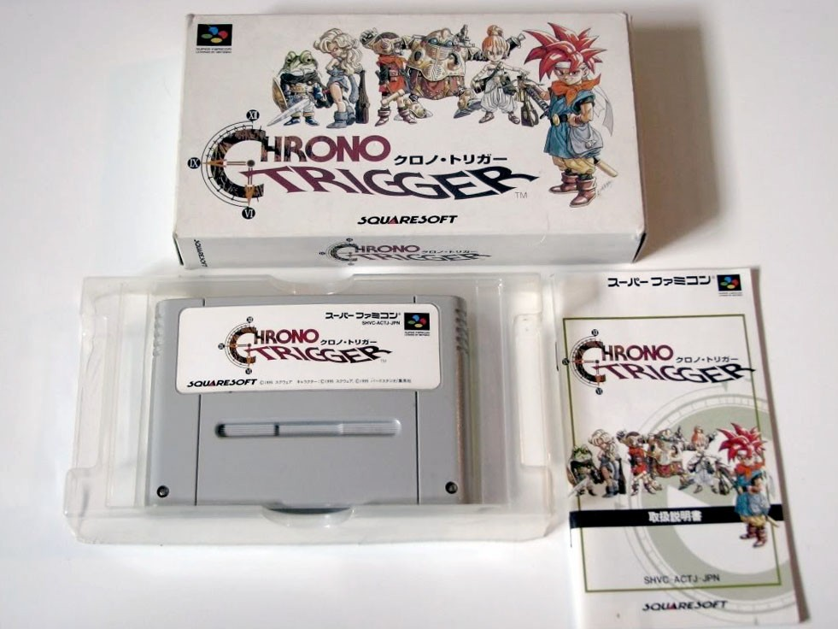

Figure 1.1: SNES Game Cartridge, 1995

As such, my method has been to focus on user-centered design to overcome the difficulties of migrating skills involved in one creative practice, video design, to a second practice – game design, or user-centered narratives. ScreenPerfect’s initial layout and idea of operation was designed with a video artist – Hannah Epstein - who laid out an idea for how an interaction might work. The interaction was duly written, then released, refined, and redeveloped for a broader audience via the inclusion of editing tools, who then created games of their own. The hope is that each new version of the tool will generate a useful echo chamber, amplifying new ideas even as it makes advanced technology easily accessible to content producers. The toolset can then be released and left for artists to use and analyze, and can be expected to run privately on optimized systems similar to ”game cartridges” from the 1990s. Rather than actual cartridges, these installation kits take the form of locked SD cards or USB sticks, which can be relied upon to hold their data in a reliable, mobile format. This means that artists will be able to install and display their own games independent of any central server, free of what the technician might decide is the context of the work. This should permit reliable installation of completed works even in remote contexts – a forest, for example, or a desert.

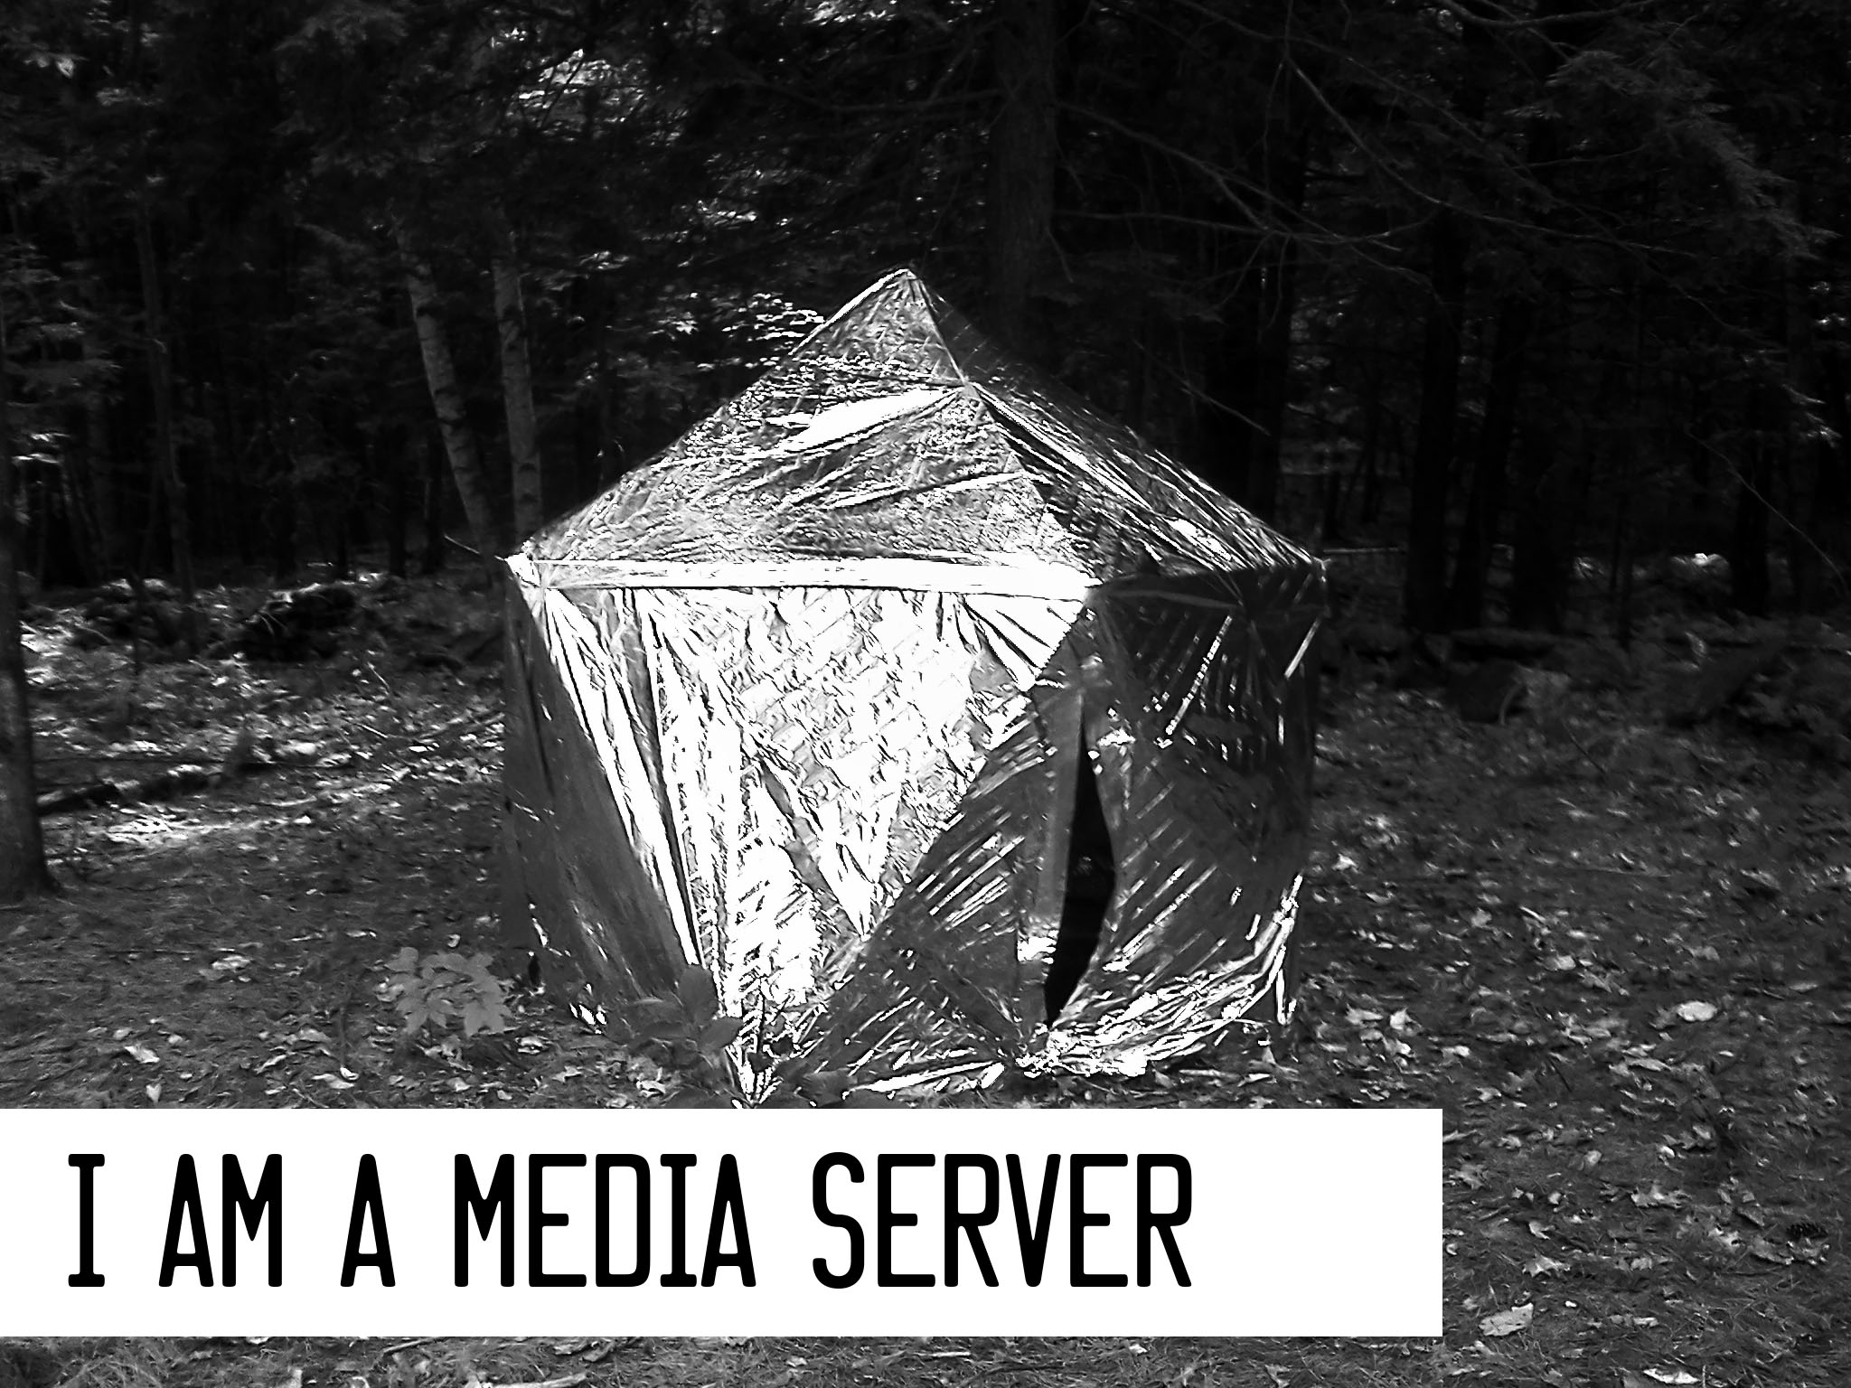

Figure 1.2: Seizuredome, S. Kochavi, A. Shulz, 2013.

A tent with video installation.

**1.4.2 Code and Theory**

The initial software of this project was developed as a response to the lack of privacy and control of various shared media sources online. The project emerged from pairing with Hannah Epstein, who had an idea for a game featuring dual screens, but no means to produce this game herself. Rather than producing exclusively an engine for a single production, it seemed reasonable to produce an entire editing environment, which would place the control of the final experience into the hands of the artist. This would in turn produce an engine that could be relied upon for public performance, but also an opportunity to easily make more than one game using this particular series of interactions. Video artists are already skilled technicians with a grasp of how to set a scene, so it seemed positive to extend their ability to easily piece together branched full-motion-video game works that would then display on the internet.

The motivation for this engine is that commercial engines tend to prioritise commercial dis- tribution and mass experience, where artist installations prioritise the direct experience of a specific work at a specific time. Although there are commercial FMV engines, they do not permit easy access to multi-screen synchronisation, and cannot be accessed offline. This meant that presenting the works developed using these systems meant agreeing to advertising, or to

sign up for an account with the company, rather than being able to turn on an appliance and serve an art work.

The engine that drove psXXYborg worked well in practice, but the installation of multi-screen technology caused many issues.

The code of screenPerfect is written wholly in javascript via the Node.JS software framework. Node is a server environment intended to permit developers familiar with javascript to write code for both the browser client and the server without switching computer languages, as has been common practice until the release of Node. ScreenPerfect’s design concept has proven popular, and in order to simplify the interface of the editing tools, it was forked by my industry partners, Bento Box—Miso – the business hosts of Dames Making Games - who are interested in the idea of new game engines as a use case for their language, Daimio (Box, 2013). Bento Box produced a clean variant of my editing interface in order to help me run a game jam to gather samples of what an FMV game might look like. In return, I gave them full permission to convert screenPerfect to their own language and to extend that engine into a new application called ”iV.”

The critical theory that underlies this practice is a combination of French poststructuralism

- Helene Cixous in particular - and contemporary writing on video games and the history of women in technology. By producing the software and content with the input of a local feminist collective, Dames Making Games, and as part of a wider feminist research network (SSHRC- funded Feminists in Games), I have grounded the work in a social justice driven practice which encourages women to take part in their own lives by learning how to interact with machines and communicate with the broader world.

**1.4.3 Game Design Research**

FMV games are an old format, relatively speaking. They have been recreated using Youtube and preserved from laser discs and DVDs. FMV and branched narrative games differ from cartridge-based action games in that they do not typically feature the same immediate feedback of numbers going up and the instant player controls of a more typical 2D or 3D ”action” game. Instead, players select what will happen next at key intervals. Older games are easy to display, so long as working hardware can be found, because they rely on consistent materiel for installation. New media interactives, particularly those on the internet, live in a malleable format. They can change, or be taken down, at any time. The experience of a console game can be had even when disconnected from the internet – in fact, the Nintendo 3DS, a pocket console, outsold every other system on the market in 2013. It is speculated that its success is due largely to the fact that the 3DS is a portable system that does not connect to the broader internet unsupervised. This reliability is something that is rare to find in more complex computers: sometimes, as argued by Don Norman in ”The Design of Everyday Things” (Norman, 2002), it is best to have a single thing do one thing really well.

Another example of portable electronic interaction is the smartphone. Mobile is a huge segment of the market, which is excellent for text messaging, talking, and playing games that separate an audience from each other, but initially seems not so great for bringing people together in the same space. The privacy of the phone initially seems undermining or distracting, but might be seen to have instead a lot of potential: people examine things one-on-one with their devices, and then will share them with their peers.

Smartphones are inherently private systems used in public places. This leads to a set of assump- tions for interaction developers: an application is a private thing, paid for, and downloaded to a private space, where a web page is a public resource that can be viewed in private on a phone.

A smartphone is also a single encapsulated controller, with all necessary inputs provided by its touch surface. For interactive artwork, this means that some assumptions can be made.

The first is that the audience of an interactive art piece is likely to be familiar with how to interact with a touchscreen, but also may be distractible. It cannot be assumed that they will download or pay for an application sight unseen for the sake of art, because that would constitute an expenditure of resources without a sample, but they can be asked to go to a web page. People commonly use their phones in public, and therefore it seems reasonable to ask them for the minimal engagement of looking at something specific, this time art served only within the gallery.

There are already game systems that choose to subvert this separation, and systems have been built to take advantage of the power of pocket computers. A notable effort is ”Spaceteam,” (Smith, 2013) a ‘Simon-Says’ game for teams of up to four players. The application pairs to itself across phones by using a common network connection, and players in the same physical space cooperate to pilot a star ship. This allows players to make use of a device with which they are already comfortable to cooperate and share an experience.

This shared experience makes it possible to privately host a public space. screenPerfect, a web application served locally, takes advantage of an assumed set of smartphone users in galleries having access to the internet in their pockets. The internet is both bigger and smaller than the wider network – the internet that includes Google. Rather than relying on the external resources of remote servers, screenPerfect provides a private wiFi point and what is called a

”captive portal” to let players pair with one another and the server, control a large screen, and interact with a piece of video art in a localized area. This means that an artist can control the exhibition space for their work, design the experience of the work, and ensure that their

audience will experience the work in a context that makes sense. It also ensures that technicians can access the underlying engine should something go wrong during the installation.

**1.4.4 Feminism, Cybernetics, and System Controls**

This work is related to various texts of feminist or woman-oriented critical theory: Haraway’s ”A Cyborg Manifesto,” TIQQUN’s ”Preliminary Materials Towards A Theory of the Young-Girl.” Haraway’s ”Cyborg Manifesto,” from 1989, reads in relation to the world before the internet, where TIQQUN’s commodification of women ten years later – from 1999, shortly before the first of a series of devastating economic crashes – more neatly quantifies the value of young woman as commodity (Cixous, 1976)(TIQQUN, 1999). Cixous’ work seems an interesting way to look through the composition of self that the internet provides to people who would like to package and produce an image of themselves. Where Haraway would rather be a cyborg than a goddess, and TIQQUN insists that young women— perfect stereotypes are the ultimate product of empire, Cixous insists on an individual self-determination and presentation, even when such seems impossible in a world where the tools for communication are totally controlled at a distance. Cixous insists on rebellion with a sense of play, and on this being the responsibility of the individual even when it seems impossible.

All of these texts have complicated thoughts about embodiment, which I have chosen not to address, as I am more interested in embodiment as the idea of a piece of writing having a perceptible effect. Code has this ability. When you touch a screen, writing – interpreted or compiled – controls what happens next. In this context, the ´ecriture f´eminine can mean literal social breakdown, or a very physical change in the environment.

Rather than expressing this work in context with Cixous as ´ecriture f´eminine, I will be using

Cixous as a reference for the idea of the alien perspective as a position of resistance within a

means of expression controlled by a neutral-to-hostile majority.

This approach addresses women as an alien construct to the more conventional world of tech- nology, which has become associated with a masculinist performance that is unnecessary for the pure structure of good rules and the development, through that, of good software. This construct is relatively recent, as Nathan Ensmenger presents in his work on the systematic ex- clusion of women from programming as a trade (Ensmenger, 2010). Although artists are central agents of production of the invisible yet tangible value of the culture industry, they are not the prime beneficiaries of the financial system that backs, stores, and distributes the results of that capital. This is capital as both skill and capital as resource distribution: computers are expensive. Getting around that face is important if we wish to supply access to contemporary media to a broad array of voices: to be inclusive, software should be the last thing that gets in the way of a work, rather than the first. This reserves the value of scarcity - the market value of the work to the ability of the artist, rather than applying the majority value to the role of the engineer. This kind of invisibility is the invisibility of good management, of any type of good administration. Like housekeeping, code recedes until something goes wrong.

To test this idea, I have approached people to produce videogames with the screenPerfect software in the context of a voluntary game jam – a type of collaborative space where participants work with digital tools to generate new games in a limited window – and then the results are compiled for display into an arcade machine for presentation.

CHAPTER

**TWO**

BACKGROUND, THEORY, AND THE STATE OF THE ART

**2.1 Game Engines**

A game engine is a collection of software designed to make it possible for a team of artists, developers, musicians, and producers to work together to produce a complete digital experience.. Traditionally, game engines are used to produce 2D or 3D experiences using assets such as 2D sprites or 3D player character/interaction models, backgrounds, interaction assets - crates, for example - music, and scripts in a programming language to tie all of these together into gameplay.

Some popular professional engines at the time of writing are Unity3D, which features native mobile integration and ease of scripting in both Javascript and C; Crytek, which comes with many high-end 3D resources preloaded for high definition graphic support; the Unreal Engine, which is quite stable and useful to experienced teams that prefer more control over their work.

There are popular hobby engines that de-emphasize programming as well, such as Game- Maker, which is prized for PC compatibility, Game Salad for OSX, and Construct 2, which is PC-only but has a powerful engine to manage game physics and interactions. These engines all assume a certain type of player interaction: they are designed to enable designers to produce specific types

of games, such as a ”shooter” or a ”platformer,” similar in style to the Call of Duty franchise or Nintendo’s Mario series. The interactions available are easily understood as a language of action by their players, provided players have previous experience with video gameplay.

ScreenPerfect is distinct from pre-existing engines. It is a piece of software custom written to encourage artists to use their own skillset in image and video creation to explore what is possible in an interactive experience. ScreenPerfect has a set of play mechanics that have been pre-written. While they can be extended by anyone who knows the language, the editing and interaction mechanic are both straightforward to use and not designed to be altered by artists. This means that artists have a consistent environment in which to place their work, which will reliably showcase that work without them needing to learn how to program - an entirely new creative skillset – in order to do so.

**2.1.1 Twine**

Twine is a game engine that allows designers to build HTML5 text narratives that branch into a choose-your-own-adventure game. screenPerfect was inspired by the popularity of both Twine and video on the internet. Twine encourages expressive type styling and elements of multimedia, including music, and well-designed game screens, but does not require these elements for a complete narrative. Twine did not yet support video narratives in 2013.

The Twine engine was popularized by indie gaming celebrity Anna Anthropy in her 2012 book Rise of the Videogame Zinesters (Anthropy, 2012). Since then, hundreds of Twines - the adopted term for narratives built in Twine - have seen release. order to do so.

**2.1.2 Multiscreen Video Technology**

Dual screen technology, or more accurately, multi-screen synchronous web technology, is one of the big new ideas being heavily backed by Google in 2013. As a consequence, its Chrome browser has been designed to support software developed with a specific suite of frameworks, many of which are wholly supported by Google. This being said, Google supports Node and Chrome both, so multi-screen technology using web browsers is accessible to people for no more investment than a new language. screenPerfect relies on Node.JS, which is based on Google’s V8 engine.

The architecture of screenPerfect is wholly new, but the concept is based on the Dataton Watchout system, which encourages producers to develop large multi-screen single video ex- periences on custom hardware. Dataton Watchout costs approximately forty thousand dollars per installation, which makes an inexpensive alternative appealing from a creative standpoint. screenPerfect permits people to use existing hardware to synch multiple videos to one set of con- trols. This is also distinct from ChromeCast, which allows people to wirelessly pair a television with a touchscreen for control and consumption of the touchscreen at a larger size.

**2.2 Theory and Politics**

Cixous’ Laugh of the Medusa predates the computer age, but perfectly and predictably describes the trouble with programming - which is a form of writing - within Laugh of the Medusa:

”Write, let no one hold you back, let nothing stop you: not man; not the imbecilic capitalist machinery, in which publishing houses are the crafty, obsequious relayers of imperatives handed down by an economy that works against us and off our backs; and not yourself.” *(Cixous, 1976)*

In this passage, Cixous chides her readers for not giving themselves the permission to write, because writing is reserved for those who might be published. This is similar to game-makers who might not produce, merely because the engines are inaccessible, or distribution unlikely. Women have had a long place in technology. Ada Lovelace, daughter of Lord Byron, has been identified as the first programmer (Plant, 1997). The ability to put rules in order, to work backwards and forwards from a desired result all along the path of the machines, is a characteristic much sought in both programmers and game designers. Both roles are responsible for rule systems that will dictate a predictable result.

In a straighforward way, ladies may not possess uncomplicated positions of economic advantage within a patriarchy, and it is against the interests of the system to permit a polyphony of input at the rules-setting level. Computers have quickly become a good job with a good chance to better one’s life. It is presently popular to assert that in the future, there will be two types of lives:

”...those who tell computers what to do, and those who’re told by computers what to do.” *Marc Andreesen, Andreesen Horrowitz*

This is broadly accurate, but not specifically. Computers are a tool, and the way that the tool is presented, held, and used, dictates the results. A computer - a machine for automating an interaction - can be made simpler or more complex to use. The device may be changed to an amplifier of force, made more opaque, or made clearer for those who choose not to learn to code, but can still understand systems of logic. If this then that is not a complex instruction set. The complex instruction sets should, rather than being encouraged to control people, be developed to be under the control of people.

screenPerfect has been designed to present the idea that a simpler system will result in a more diverse body of work. It dictates nothing whatsoever about content, presenting instead a

simple system of switches that permits the author the broadest possible control over simplified interaction sets. It is implied that these interactions will lead to a coherent narrative, but it does not dictate what content a trained video artist might place within it. The voice of the artist is therefore primary in the work, permitting them to decide what they would like the work itself to say.

By simplifying the process of game design and displacing its nexus from the computer to other design tools, technology is repurposed to be one tool among many. This displaces technology’s primary position and refocuses the work on the intent of the artist. This is an implicit system of resistance to the narrative of technology inevitable victor over humanism: people can once again tell computers what to do, and extend themselves via their tools.

CHAPTER

**THREE**

SOFTWARE DESIGN, INDUSTRY ENGAGEMENT, AND HARDWARE DESIGN

**3.1 Software Design**

A software interface is the part of the software that a person interacts with directly where a software engine is the part of the code that detects and defines what a computer can do with that interaction. The interface of software is just as important as the engine, however, because a poorly designed interface will confuse a user, thereby rendering the experience of using the engine potentially opaque. screenPerfect’s roots are as a software engine, which takes user action and then does things with it. The user interacts with the interface, which speaks to the engine, which then returns values to whichever interface the user has selected.

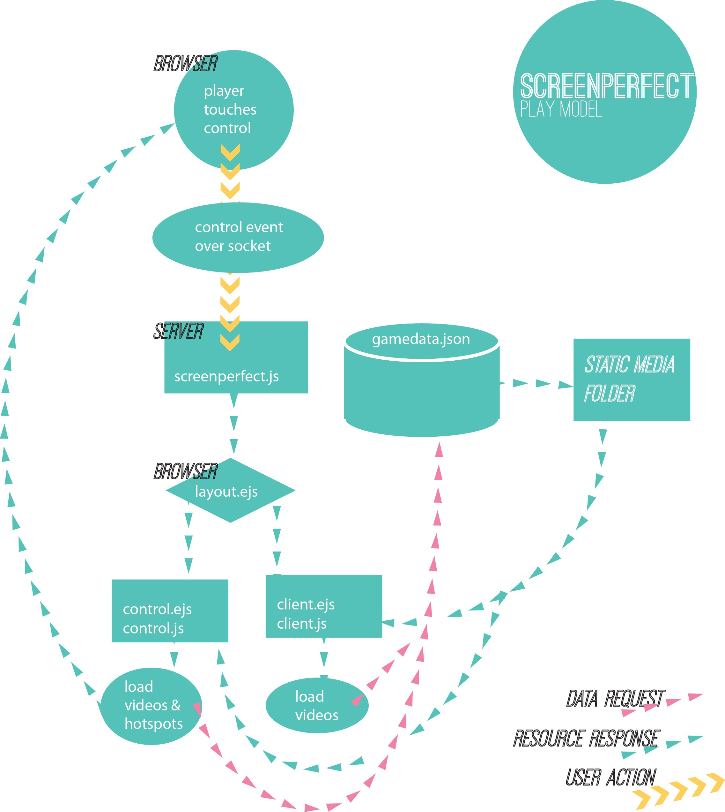

Figure 3.1: screenPerfect software communication model

**3.1.1 screenPerfect Engine—Interface Layout**

In the case of screenPerfect, the interface is laid out in three parts. The first part is the setup screen, which is where game designers load their media (both videos and static files) and lay out the links between those files. This is the essence of a game made in screenPerfect: which choice will a player make to navigate the system as designed by the artist?

The further screens are the client and control screens. screenPerfect supports up to ten cli- ent screens and ten control screens, although the interface only exposes a polyphony of client windows, while restricting artists to a single control set for simplicity’s sake.

The layout of screenPerfect’s editing tools did not work very well for authors who were not already part of the prototyping process. Therefore, as part of the extension of the software for NoJam, Bento Box——Miso reauthored the editing interface of the software. The final editing layout is clean, though less expressive than the original design. Rather than hidden tabs, everything is displayed on launch. This permits authors to see their video files during the entire game editing process, which greatly speeds game creation. What follows are screencaptures of the pre-fork game jam variant of screenPerfect.

Figure 3.2: screenPerfect NoJam editor, Asset Population tab.

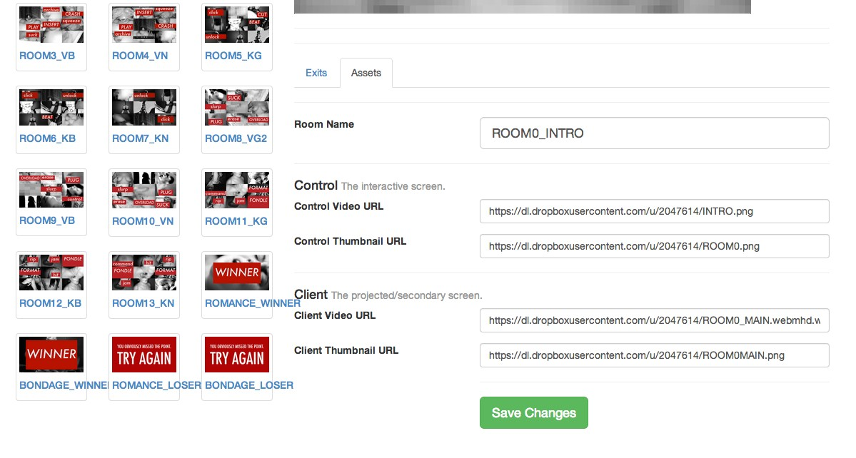

Figure 3.3: screenPerfect NoJam editor, Exit Population tab.

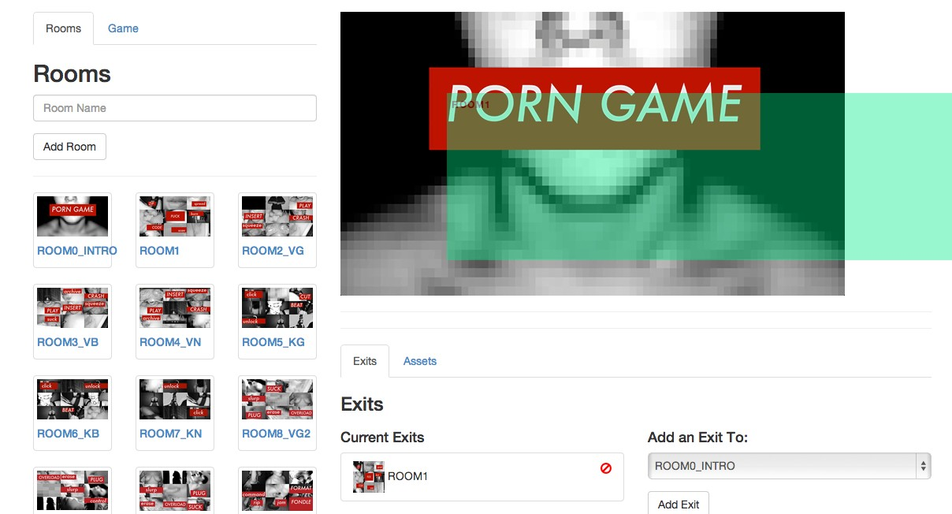

**3.2 Design Research**

**3.2.1 Artist Collaboration**

screenPerfect began with an artistic collaboration, where as a programmer, I worked closely with an artist to reproduce the technical elements of a working practice in order to make it available to other artists in a similar field. This specificity allowed us to develop a very simple tool that solves a minimal set of problems in a tidy fashion. As a developer, it can be difficult to tie work to a given set of problems, or to ensure it has value to an audience outside oneself. Therefore, collaboration gives access to a set of problems that may seem easy

**3.3 Development Methods**

**3.3.1 Agile Development with an Artist Partner**

The Agile method of software development is based on the Agile manifesto, much as the un- derlying feminist elements of this project are based on the Cyborg Manifesto, and Cixous’ manifesto for the *´ecriture f´eminine*. Agile is a response to previous software design practices, called ”Waterfall,” where software frameworks are laid out and heavily documented in advance of production. Waterfall methods are popular in major software companies, which rely on ex- tensive documentation to communicate between business units. Waterfall emphasizes planning over software production or delivery deadlines.

The idea of Agile was described in 2001 by a group of software developers (‘The Agile Manifesto’,

2001). By using an Agile practice of responsive, user-centered design, screenPerfect’s interaction model was designed through a series of discussions with key stakeholders, followed by iterative

code revisions to a rough first prototype. This can be seen as a hacker-oriented means of devel- opment, reflecting Plant’s statement that reverse engineering - ”starting at the end, and then engaging in a process that simultaneously dismantles the route back to the start” (Plant, 1997). Agile specifically emphasizes individuals and interactions over processes and tools, working soft- ware over comprehensive documentation, customer collaboration over contract negotiation, and responding to change over following a plan (‘The Agile Manifesto’, 2001).

The screenPerfect development process emerged from a series of linked videos on YouTube, as laid out by Hannah Epstein. We then reviewed strengths and weaknesses of this model: the ability for a large audience with public interlinked video files, but the downside of long load times and ads on pages detracting from the video content. In addition, this required uploading films at low quality to a remote server. From the initial prototype, we asked how the process could be improved, particularly for an exhibition context.

The game processes laid out in Youtube were converted to a ”how might we” - a series of static files presented as interactions in still film. Hannah Epstein laid out an idea of how the video screens should work together, and I confirmed that this system was theoretically possible using websockets - a communication protocol - loaded into a Node.JS application. From there, I wrote a Node app that served basic video files to multiple browser screens simultaneously. This started as a chat application, serving text to three screens simultaneously over websockets. We then replaced the text with video files, layered a control structure over the videos using plaintext JSON files to replace a reliance on a database structure.

A database was not originally required for psXXYborg or later games, because installing a data- base is an additional step that nontechnical end users cannot be relied upon to find straightfor- ward. Every step of the development process was intended to result in code that is legible to

anyone who can read javascript, while being absolutely straightforward to use for a nontechnical video author.

In development conversations, it became clear that YouTube, in addition to having many dis- tracting advertisements, was very slow to load. This is a problem with reliance on external networks: they cannot be as fast as locally served files. Hannah specifically emphasized speed, smooth loading, and video based in static rather than streaming or live files. These needed to be served within a closed environment to an attentive audience.

Scripting languages are especially good at this type of development work. I reached out to other developers and asked how they would solve this problem, and they came back to me with a variety of answers - some used PHP, some used Python, all of them relied on JS for their front end. In researching different ways to solve the basic problem - passing a variable back and forth through wireless technology to select two on-screen videos at almost the same time - I discovered the Node.JS software framework, a software package designed to permit developers to use Javascript on both the server and client side of a web application.

Hannah relied on the h.264 format for her video production, which necessitated an early reliance on the Safari web browser, as HTML5 video does not yet have a settled public codec. Due to conflicts relating to codec patenting, one of many such conflicts that underly the ”free” internet, Safari supports H.264 where Chrome supports webm via the V8 engine, the same engine that supports the Node framework. Webm is a compact video format, which results in smaller file sizes and lower bandwidth costs, which eventually affects both load time and playback lag on client machines.

Overall, agile worked for this process by allowing a response to user requests for code changes and information rather than forcing work to fit a standard pre-set from above. A waterfall

process would have simply not been flexible enough. By working in small steps back from a pre- set destination with total freedom as to how the code actually came together agile allowed me to demonstrate different working parts of the software as they came together. The documentation for the project is tied into the code commits, and inseparable from the actual written code within its archive.

**3.3.2 GitHub and Open Source Software**

The development of screenPerfect is dependent on a variety of external technologies. Although relatives and derivatives of Google’s V8 system are foremost among these, there is also a de- pendence on the licencing and mindset of the open-source movement, and the GitHub software repository system.

Open source software is not the same as free software, as provided by structures such as the GNU General Public Licence. Open source is the peer reviewing system of software. Open source means that even if a given piece of software compiles to a single program which can then be distributed for use on the desktop - as screenPerfect does not - the code that goes into the executable file is freely available on the internet, to be changed, supported, and developed by the population of software workers who exist in the broader world. These developers may work on closed or open source projects in their usual working time. They may be very skilled or quite new to development work. What matters is that the software’s code is then shared publicly, where it can be reviewed, compiled, extended and changed by anyone at all.

The intent of open source is that anyone may learn from such freely-shared information, and anyone may contribute to the collective knowledge base. There are some obvious problems with open source. One of the clearest is that with intellectual property out there for free, it is a challenge to make any money on an open project. The other is that there is no way to guarantee

quality: one takes what one can get, although it is assumed that contributions to projects are made in good faith, and major project contributions are checked by trusted individuals before they are published. For example, the Mozilla project relies on contributors whose code is applied to the codebase after approval by certified reviewers.

**3.3.3 Licencing**

One of the ways these problems are dealt with is through licensing. The Creative Commons at creativecommons.org expresses their mission as follows: ”Creative Commons develops, sup- ports, and stewards legal and technical infrastructure that maximizes digital creativity, sharing, and innovation.” It is therefore an appropriate open standard license for creative practice. A preferred license for software development is the MIT Licence, which is closer to the Gnu Public Licence, but does not preclude making money from one’s open source work.

**3.3.4 Science Fiction Inputs**

My own idea for how this project would work is taken from Cory Doctorow’s Pirate Cinema, which features a scene wherein characters climb trees, and using pico projectors already built into their phones, assemble a movie theatre from nothing more than sheets and ropes in the trees (Doctorow, 2012). I felt this sort of mesh-networked sharing is much more likely than a continued reliance on the surveilled internet for sharing copyrighted and copyrighted- material derived works. Since I could not find a system that would permit this type of sharing on the internet, I felt that this project would provide a good chance to build one.

**3.4 Industry Engagement**

**3.4.1 Game Jams, A Design Method**

A game jam is a variant on the hackathon, which is a type of prolonged effort at taking an idea from concept to finished product in a limited period of time. Game jams are related to design charettes or parallel prototyping (Martin, 2012)(Martin, 2012), a method whereby participants rapidly prototype a design idea over a short, intense period of time. A jam - or hackathon - gives registered participants a common area and space to set up their own supplies, and a theme. The group members come to the event with an idea and possibly some resources - video files, sound capability and so on - and use the jam time to assemble a game.

Generally, a game jam will produce a panoply of small game ideas with fleshed mechanics but simple art and sound design in order to demonstrate a possible path forward for a device or piece of software, which will then be polished at a later date, and presented to the indie community either online or at a social event. Sometimes these works will then go on to be finished commercial products, or are intended for further consumption at major conferences such as Indiecade or GDC. These conferences can further the careers of the developers by providing access to funding bodies: publishing houses, or in Ontario, the Ontario Media Development Corporation. Other funding sources can include research groups, such as the SSHRC. By classing game jam development as research, participants released from the need to make commercially appealing works. In the case of Dames Making Games and screenPerfect, funding came from the Feminists in Games project, headed by Jen Jenson of York University, and GRAND FRAGG, a research project dedicated to expanding the diversity of voices represented in gaming.

Game jams can be time consuming to prepare, as they involve a great deal of communication on the part of the organizers. In order to run a jam, one must open the application period

well enough in advance to ensure a large cohort of skilled users who are likely to be interested in producing content with the available tools, or interested in exploring new tools on offer. Typically, jam attendees have a theme suggested - ”Mother May I” or ”Snacktember” being a few run in 2013 by the Dames Making Games - and then participants bring their own preferred technology to produce a fast prototype over a weekend.

**3.4.2 Dames Making Games and Game Jams**

Dames Making Games (or DMG Toronto) is a non-profit community organization based in Toronto dedicated to supporting dames interested in making, playing, and changing games. In short, we want to build an **inclusive** and **engaged** local com- munity of game-makers. Our community isn’t women only, but it is women-driven. *from the DMG.to website, accessed November 27, 2013*

The Dames Making Games are a community group in Toronto that work to promote women in video games. They have been funded in part by FiG (http://www.feministsingames.com) and in part by member donations. I am an original director and advising director with the organization, which has given me ready access to a test audience for my ideas with regards to development tools. The Dames Making Games use the game jam method to introduce women and allies to simple game development tools. This provides a straightforward introduction to concepts of computer logic and programming for some people, to video game art development for others, and video game sound production for still others. Some develop system mechanics, some design whole levels or game narratives.

The point of the DMG is to promote access to this field to people other than the 18-to-35 year old males who form the primary demographic for the video game industry (‘Game De- veloper Demographics: An Exploration of Workforce Diversity’, 2014)(‘Essential Facts About

The Computer Game Industry’, 2014), in the hopes that a diverse population of game makers will produce a diverse population of games.

The Dames Making Games are interested in screenPerfect as it provides an underlying template for a game-making system that might be easier for newcomers to use than other freely available game engines. The other two members of the Board of Directors of DMG are Cecily Carver and Jennie Faber, who, in exchange for development work as members of Bento Box, have since forked screenPerfect to become a more elaborate engine, called iV in honour of the idea of a Twine engine that created branched narratives from Vine videos (Klimas, 2009).

**3.4.3 Bento Miso and Bento Box**

Game jams require both space and people who are interested in working on games. A themed game jam, such as No Jam 2, which was designed to test specific software, requires a specific audience and support. In order to access that space, I worked with the Bento Miso co-working facility here in Toronto, with OCADu’s game:play lab and Emma Westecott, and with Bento Box, a development company that runs Bento Miso as a not for profit co-working facility.

Miso is a not-for-profit community coworking facility that serves as home for both Bento Box, a local development hub, and the Dames Making Games. It is also the hub of a great deal of Toronto’s independent game development community. Miso/Bento Box offer professional support and development advice to game developers, and I felt there was a good match between their professional skillset and my research interests. The Dames Making Games group regularly run a jam in November, and felt that screenPerfect - a new software designed to be accessible in a short time frame to people with extant skills - would be a good match for the audience associated with the organization.

Bento Box was also at the time seeking an engine that could display the capabilities of their private computer language, Daimio, which offers users the ability to reprogram work on the fly in the browser without being a trusted network source. Therefore, I accepted their help and their offer of hosting the jam in return for giving them permission to fork - copy, reproduce, and extend - my engine under their name.

Miso, and Bento Box, offered to help me with coding a more accessible front end to the screen- Perfect engine in time for the jam, so that I could get feedback on the system mechanics rather than just the interface.

**3.4.4 NoJam 2: Video Video**

DMG have a great deal of experience running jams, and therefore, I partnered with DMG/Miso to access to a group of skilled animators, filmmakers, and gamemakers. By partnering with them, I gained ready access to their community population, and they gained access to my software. One of the most common difficulties with game jams is that the short timeframe can cause a lot of frustration to new non-programmers: they spend a lot of time wrestling with tools, rather than generating the content of their games. The DMG would like to make it more straightforward for their membership to generate games and interactive narratives in a short period of time.

No Jam is a two-week jam scheduled by the DMG in November. In order to prepare screenPerfect for the jam, I handed over the basic engine to Bento Box - the production arm of Miso - who cleaned the interface elements and released a web-based version of the software for users. This was a win for them, as they were able to refactor my local code base to take advantage of a new language they have produced, called Daimio. Daimio, being a dataflow language, is ideal for

describing choice patterns as they relate to a database. ScreenPerfect is a good engine match for types of games that rely on interactive choices.

As a pair, Dann Toliver - architect of Daimio - and I worked together to clean up the javascript elements of screenPerfect for speaking to the Daimio dataflow language. The group then released a refactored version of the code in time for No Jam, so that our participants could get a clean version of the software to work with. This was challenging for me, as it involved a great deal of trust, and moved the software away from how I had initially envisioned the UI. In particular, we needed to scrap an early idea for a branched narrative ”tree” display, which was not included, although it had been planned all along.

After we received No Jam applications, we went through to choose participants who seemed interested the theme and the software restrictions, sent out acceptances, ordered food, and gen- erally set the dates. Applicants were provided diaries to record their working process over the course of the week. The first weekend of the jam consisted of workshops from a variety of spe- cialists to provide direction in how to think about the software and the jam process as research. My presentation is included in Appendix C, consisting of how to work with the screenPerfect software, how to think about multi- screen video, and how to think about technology as a form of creative practice.

The applicants were then sent home for a week to work on their video projects, and asked to document their ongoing process with one another on a private Google Group. Most participants ignored this request, which left us with relatively little online material.

On the actual weekend, we asked that participants arrive with the majority of their video content and design prepared. There were uneven responses to this request, which strongly affected the ability of participants to produce a finished game by the end of the weekend. I interviewed each

group early in the process, and then later polled them with informal questions regarding their experience with the software.

The group experience with the software proved interesting. Accomplished filmmakers had a bet- ter time with it, but the most surprising response was from young, self-identified gamemakers, who rather than exploring what was possible within the context of the software tools, decided instead to try to use them to reproduce existing game types, many of which were totally incom- patible with the software’s design. Of particular interest was the group who tried to reproduce a classic Japanese roleplaying game within the context of video: this did not work so well, and they continued to work at it even after it became apparent it was unlikely to go well. The game itself remains unfinished, but deserves mention as the most unique and possibly stubborn effort. Used to working with uncooperative tools, the participants seemed unsure how to cooperate with a tool clearly designed to a single end.

Despite this, No Jam was a success, with nine groups producing diverse works on ideas such as how to express a practice of mindfulness, how to work with pornography in a way that forces the viewer to interact with what’s happening on screen, exploring systematic violence against women, exploring narratives of imprisonment, magic, and in one unique case, permitting a puppet to escape a toy box.

In setting up No Jam, we did present at least one workshop on the importance of the personal narrative in producing creative work, which may have influenced the results. Game jammers mostly described their interest in producing work that was finished, and one jammer explicitly stated that she was pleased to have had a finished work at the end of the jam, this being an uncommon result for her when she had to learn the usual round of new software each time. No Jam resulted in at least five ”finished” works, which have since been included in several exhibitions around the city, including the December and January Toronto Long Winter series.

CHAPTER

**FOUR**

HARDWARE DEPLOYMENT IN LIMITED LOCAL SPACE

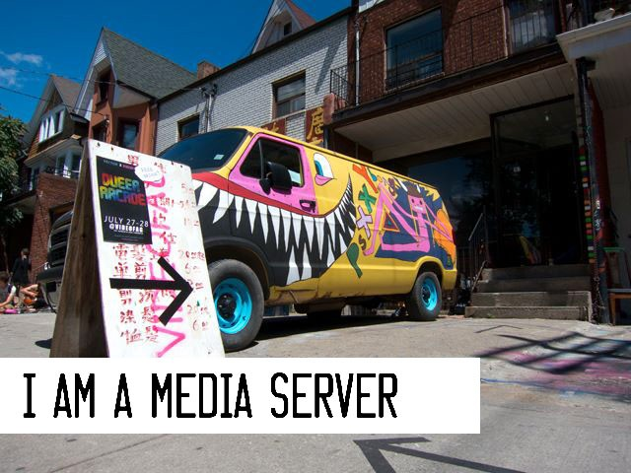

Figure 4.1: Hannah Epstein psXXYborg at VideoFag, 1995

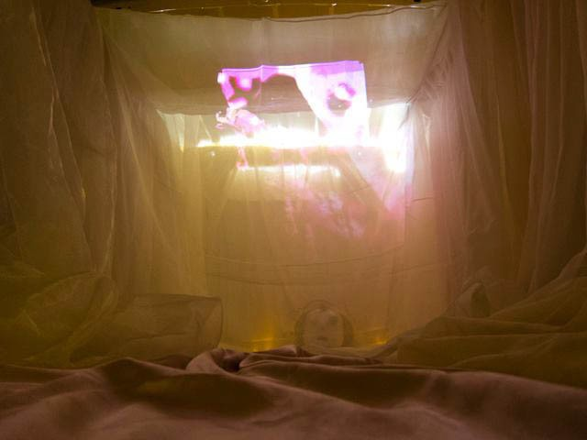

Figure 4.2: Hannah Epstein, Alex Leitch, Sagan Yee psXXYborg at VideoFag, 1995

**4.1 Public Installations**

During the course of this project, games made with ScreenPerfect had many public outings. We installed psXXYborg specifically in a variety of spaces, and there were a number of design approaches to the construction of those spaces, governed mainly by Hannah Epstein.

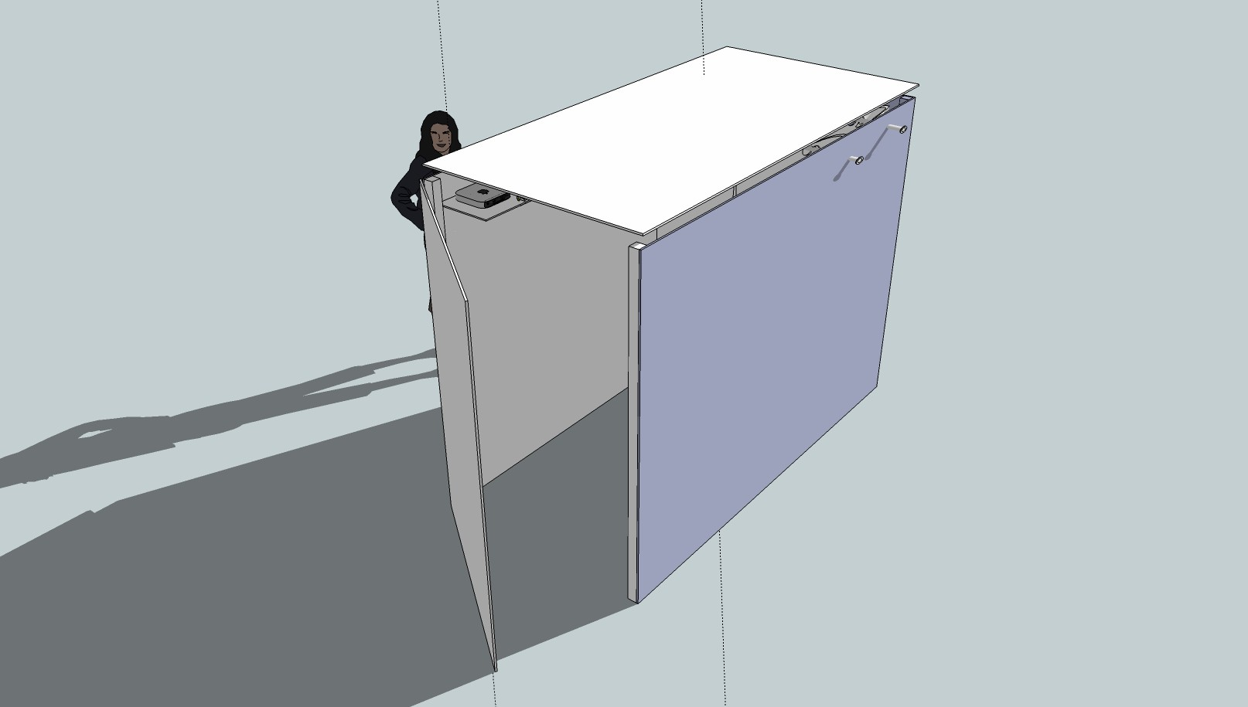

Figure 4.3: Alex Leitch

Concept for collapsible projection space 2013

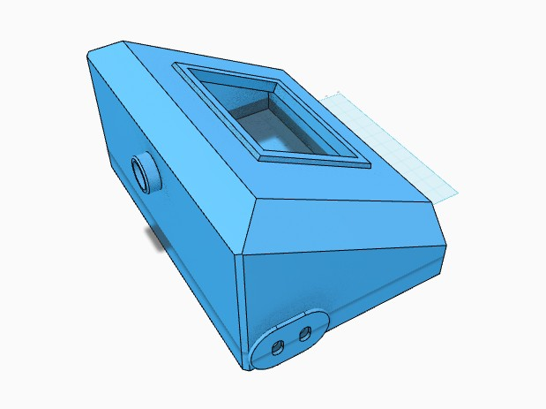

Figure 4.4: Alex Leitch

Concept for portable arcade box, 2013

**4.2 Hardware Design**

There were many hardware difficulties associated with early builds of screenPerfect as psXXY- borg. The software is dependent on open wiFi and high bandwidth, a stable computing system, a variety of tablets and other devices, and none of these things are confirmed to work together. Idealistically, the software is open. In reality, it is incredibly difficult to build a new software system to work on broad platforms, and this ended up being an unrealistic goal.

After installing PornGame at the Art Gallery of Ontario for a Long Winter event, even the software developed by Miso failed repeatedly to load correctly on a variety of devices. This resulted in the need to reprogram the psXXYborg build of the software to work within a limited network, and from there, I began to research what it would take to adequately display these

time-based works. The answer seemed clear: A limited hardware system with a consistent environment, similar to a video game console such as the Super Nintendo Entertainment System.

With that in mind, I acquired a Raspberry Pi, a new type of microcomputer designed to be used for learning and prototyping new systems. The chief problems on display by screenPerfect were connecting at all, running the application consistently in hot temperatures or unreliable environments, and getting the various videos to display adequately on mobile and non-mobile systems. In addition, the many installations of various games in public began to imply that people love interacting with things, but that computers are unreliable in a public environment.

I observed that people are willing to use their smartphones publicly, but mainly to access the external internet, or messaging services while they are in public. ScreenPerfect, which relies on the form factor of a mobile device as well as a powerful multipurpose computer, did not seem to work so well in this context.

This led me to consider how people interact with the internet publicly, and to consider topics of privacy and public space, and how these problems have already been solved by galleries and coffee shops wishing to offer their clientele data services to promote engagement.

In public spaces, internet is supplied by wiFi, which comes through a specific type of router known as a ”captive portal.” A user will walk into a shop, attach to a network, and ”sign” an agreement to make use of the wiFi within that space.

Normally, the wiFi will then give them access to the external internet - the internet as supplied by a major ISP. This is not necessarily what needs to be supplied, however. In the Subnod.es project, hosted by Eyebeam in NYC, users pair to a captive portal which is also a server, supplying access to an entirely private chat room, which is available only to users on the network supplied by the captive portal itself.

This seemed like an excellent answer to the question of how to supply screenPerfect applications so that users can pair to them in an intuitive way, with a minimal amount of hardware that is easily maintainable, and I therefore set about building a Raspberry Pi that would supply two things: a wiFi signal and a server that serves an instance of screenPerfect where users can experience at least one, but hopefully more, screenPerfect games.

In this, I hoped to address a few problems. The first is that downloading applications to a smartphone seems invasive, particularly if those applications are experimental or site-specific, as - post-psXXYborg - I think that screenPerfect games are when they are at their best. The next is that web applications are very much not user specific - they can be experienced anywhere while they are on the open web, even if their content is intended to be restricted to a specific type of installation, or requires it for best use.

A small, portable piece of resilient hardware (a Raspberry Pi stores its entire operating system on a single SD card) seemed like an excellent answer, which would provide an appliance-like container to serve this software, and also provide a solution to the problem of external bandwidth reliance. By serving the application locally, there is no reliance on an outside pipe. A copy of the game can be sold, customised, and stored in a collection, if such is desired, or installed in any kind of specific cabinet for later use.

I decided on the Pi specifically because it is a cheap, accessible, reproducible system with a broad community of access and support, with the ability to include hardware controls where necessary. This type of system could also be built out on any leftover PC using a build of the Debian linux system.

**4.3 Physical Deployment on the Raspberry Pi**

One of the earliest problems screenPerfect has been compromises in how the software is served to players and artists. Reliance on public internet is difficult, because the internet is not always available. WiFi is taken for granted in most institutions, but it is not always reliable, and the most interesting installation zones, such as the forest, may not have internet available at all.

There are other challenges to public deployment, such as leaving a valuable production environ- ment out in public, or requiring a technician to look in on specialized equipment. Both of these restrict the venues permitted for public display of work. Also limiting are instances where work should be deployed near people consuming alcohol, which is notoriously bad for electronics.

This chapter addresses my central idea on how to repair the gap between excellent idea for web-based deployment, and the physical reality of gallery spaces with sharply limited resources available for persistent software deployment.



Figure 4.5: Abe Shulz and Sage Kochavi

Seizuredome at FireFly 2013

**4.3.1 Problems and Complications in Display**

These issues have been revealed through various installations of screenPerfect in public space. Exhibiting in a van, in a park, and in an institution with limited bandwidth revealed a clear set of questions around improving installation circumstances. screenPerfect needed to be an arcade box, similar to those used for years in fighting games in bars.

Some brainstorming resulted in the following scenarios that a reasonable arcade machine would need to address in order to present advanced work to the new, highly exclusive exhibit scenarios.

1. Data service to an external source cannot be assumed to be available.

2. The exhibit is assumed to be displayed in public

3. The environment is assumed to be meterologically hostile - hot or cold, wet or very dry, and to be hosting at least one party, such as an art opening, possibly with music

4. The exhibition is assumed to be supervised by technically untrained people.

5. The emphasis of the work should be on the work’s display, rather than on a laptop screen.

6. The collectors of the work are assumed to have extremely limited resources for ruggedized workstations.

7. Any host-provided data carriage for external connection - wiFi - is assumed to be over- loaded by default.

These are all very real constraints that impact display of new media art. We use computers for work and play, but we still separate our lives into periods when we pursue one or the other, and we still have boundaries between our personal and public lives. To use the same machines to display art as we do to build the work is to reduce the work from something approachable to

any other tab in a computer. New media works especially must be seen within their exhibition context to be understood.

**4.3.2 Subnod.es and Public Private Space**

This project has a precursor using similar technology builtat Eyebeam in New York in 2013. Subnod.es uses a captive portal similar to my own, based on the inexpensive Raspberry Pi framework, to display a chat client to only the local environment. The differences are substantial, although mainly located within the code. Subnod.es relies on an external DNS being made available via the actual subnod.es software, and depends on a different collection of software to serve the portal proper. It is also built such that those library dependencies are inseparable from the main project script.

The chief concern of subnod.es I have not yet mentioned: subnod.es was built as a response to concerns about communications privacy in North America under the NSA. Specifically, the author is concerned that people behave differently when they are watched, a subset of the concerns generally associated with panoptica and totalitarianism. While I have not specifically structured screenPerfect’s Art Portal to address these concerns, it has been built to be largely private. It serves an application to a limited selection of a public space.

The assumption of the Captive Portal Art Machine is that galleries have limited resources, but that people who go to art galleries almost certainly have access to a smart phone, which is a form of private space. Smart phones are people’s own homes, and are built to assume that they will stay with their owners at all times. This means that to install an app is to ask a lot of a viewer: specifically, it is to ask someone to bring an application into their private space without getting to sample it first. To contrast, serving that same application on the broad internet is to entirely delimit the context the art may be experienced within, which reduces its

scarcity value to almost nothing while simultaneously removing the curator’s ability to set the context of an exhibition experience. This means that it’s unlikely an artist can be compensated in any conventional sense, despite their large audience, and also means that the curation of the exhibit is no different than the ”curation” found on Tumblr. This seems to me to be a negative outcome.

A better outcome might be to make a limited public space available in a private context, and this is what we are doing when we ask that people open their phones and look at a website. The Internet is, famously, the new public space. By presenting a web application using public technology within the exclusive context of the gallery - or desert, or forest - we take control again over how our art is presented, and from there, how it can be consumed. A gallery or exhibit space can be set up very specifically for the benefit of an audience in a way that the internet in general cannot be, and web technologies are uniform and affordable in the way that more custom projection design software is not.

This sense of limited private space is key to the code-switching that human communication relies on. We are not the same people in public as we are in private, and we are again different people when we are in different publics, work to the street to school to the gallery. Technology that sensitively addresses these different code contexts seems likely to benefit its authors and its users both.

**4.3.3 Materials and Supplies**

**Raspberry Pi** The Raspberry Pi is a full linux computer the size of a large credit card. A Raspi runs Debian linux off of a common SD card. **32Gb SD Card for Raspberry Pi** This is where we place the operating system and software for the Pi. **USB wiFi dongle** Edimax-based wiFi USB dongle, for serving wiFi hotspot on the Pi. **USB flash memory** For transferring or storing

complete programs authored on external systems. **Keyboard and Mouse** For initial computer setup. **Ethernet Cable** Standard cat5 ethernet cable for programming remote. **HDMI TV and cable** Used as a monitor for the Raspberry Pi. **Micro USB and power supply** Power for the pi. **Mac or PC computer with USB ports, ethernet port, SD Card reader** Required for raspberry pi setup.

**4.4 Background for Linux Commands**

sudo means ”do this now even if I appear to have insufficient user permissions” in Linux apt-get is an inherited ”package manager” from Debian linux. ”Dependencies” are the software your software requires to run, Debian uses apt-get to manage them. Things that follow sudo are commands.

**4.5 Setting Up The Raspberry Pi**

**4.5.1 Windows 7 SD Card setup and first boot**

This section is written for a Windows 7 environment, and is based on the common tutorial at <http://learn.adafruit.com/adafruit-raspberry-pi-lesson-1-preparing-and-sd-card>

1. Connect your main computer to the internet.

2. Download the most recent Raspbian distribution image from <http://www.raspberrypi.org/down>

3. Download Win32DiskImager from the greater internet. This is preferable because it allows you to write image backups to your harddrive.

4. Using Win32DiskImager, write your Raspbian distro to your SD card on your main com- puter.

5. Eject the microSD card and stick it into the Raspberry Pi.

6. Plug in your keyboard, and plug a mouse into your keyboard.

7. Plug in your HDMI cable and monitor. Turn them on.

8. Plug in the MicroUSB cable for power to the Raspberry Pi.

**4.5.2 Configuring Raspbian**

Once the RasPi is turning on, it needs to be set up to include all of its software. Turn the Pi on, and wait until the blue configuration screen comes up. Figure 4.3: Early RasPi Configuration Screen

1. expandrootfs Expand the boot system so that you will not run out of onboard memory for software.

2. memorysplit Reduce the GPU to minimum, because we will be using the raspi as a headless server from the command line.

3. changepass Change the password so that the Raspberry Pi will be less easy to hack.

4. ssh Enable SSH so that the pi will be accessible from an external computer. When done, select finish to exit. Type sudo reboot to restart the raspi.

**4.6 Software Setup for External WiFi Access**

A wiFi antennae can be used for one purpose at a time: it can either be used to access the external internet, for acquiring software to install into the raspi, or it can be used for serving a hotspot. It cannot do both at the same time. To load the pi up requires external access, so we will be loading that first. You must configure your wiFi before plugging in your wiFi antenna.

In Linux, there is warning you if you mistype a folder name, say, adding an ”s” to ”network”

to make it ”networks.” If you would like to confirm your folder name is correct, try typing

”ls /etc/” to list the contents of that directory. Network is a default folder, and Interfaces is already present at first boot, so you can make sure your things are all there before you really get started. The way to tell you have done something wrong is if you type the below command and an empty new file opens. You are editing a file here, not creating one. At your console prompt, type the following:

1 s u d o n a n o / e t c / n e t w o r k / i n t e r f a c e s

This opens a text editor called ’nano.’ Enter the following into it.

1 a u t o l o

2

3 i f a c e l o i n e t l o o p b a c k

4 i f a c e e t h 0 i n e t d h c p

5

6 a l l o w - h o t p l u g w l a n 0

7 a u t o w l a n 0

8

9 i f a c e w l a n 0 i n e t d h c p

10 wpa - s s i d " n e t w o r k n a m e , c o m m o n l y c a l l e d a n s s i d , g o e s h e r e "

11 wpa - p s k " p a s s w o r d "

Then type CTRL-X and Y to save your file.

1 s u d o h a l t

Plug in your wifi antennae, pull the Raspberry Pi’s power cable, and plug it back in. This should make the raspi’s antennae turn blue as it turns on. This little blue LED will frequently be the only way to tell something is going correctly or incorrectly, so it is an excellent tell that your machine is running.

Plug in your wifi antennae, pull the Raspberry Pi’s power cable, and plug it back in. This should make the raspi’s antennae turn blue as it turns on. This little blue LED will frequently be the only way to tell something is going correctly or incorrectly, so it is an excellent tell that your machine is running.

The case in the following figures is a modification of an open-source design supplied by Thingi-

verse.com user DrewTM. It is Thing #114244 and can be found at h[ttps://www.thingiverse.com/thing:114244.](http://www.thingiverse.com/thing%3A114244)

Figure 4.6: Raspberry Pi with functioning wiFi antenna

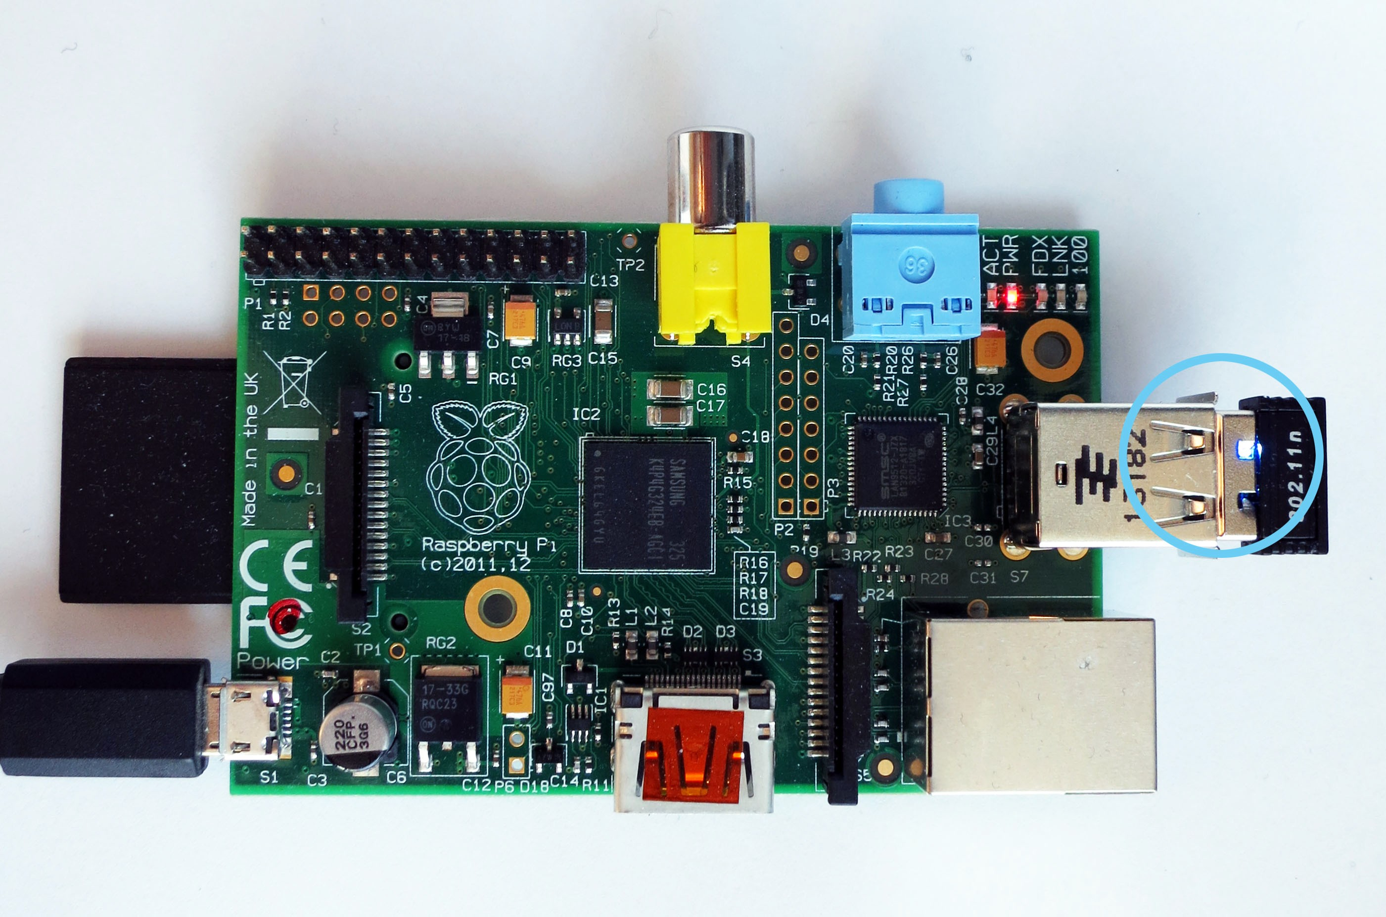

Figure 4.7: Raspberry Pi in Thingiverse case

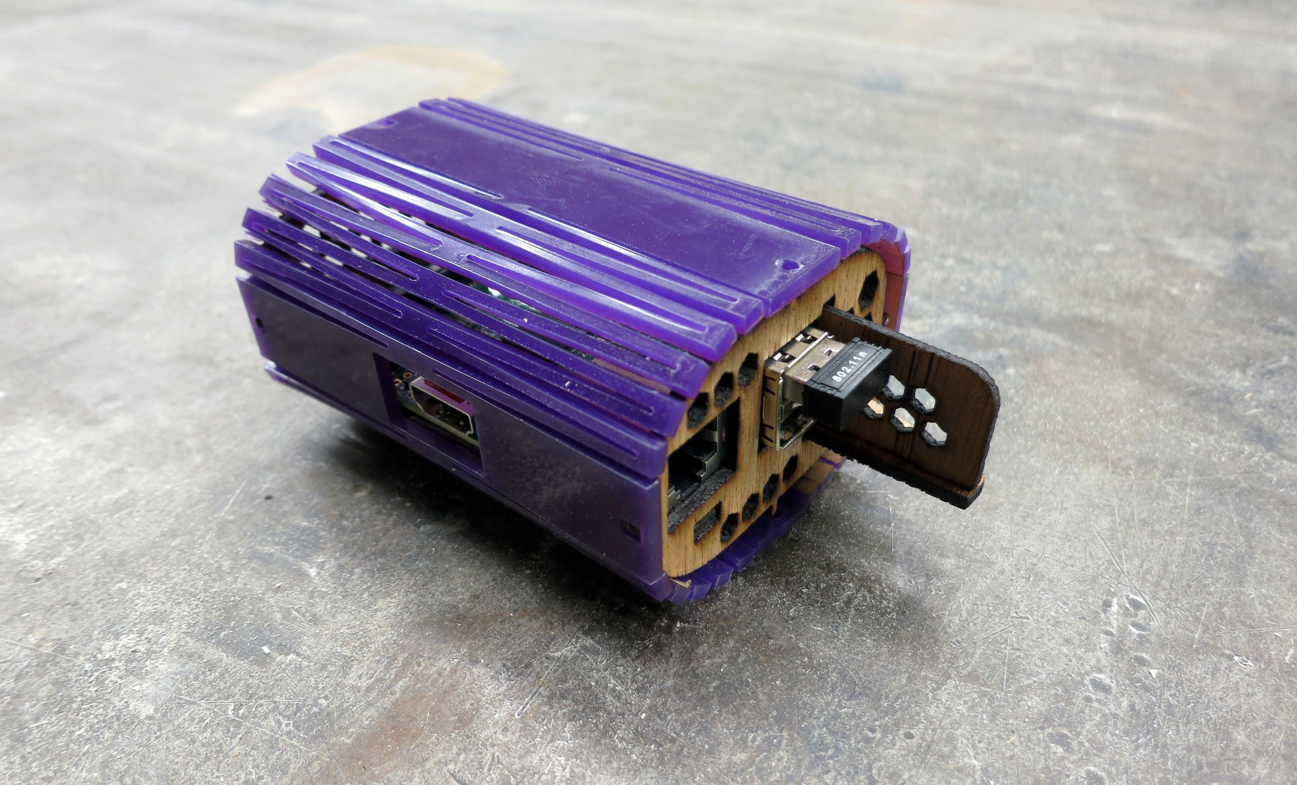

If all went well, you’ve now connected to your own supply of wireless internet. This will not work if you are using an 802.1x network, such as those within OCADu. On your own home

network, however, type:

1 s u d o apt - g e t u p g r a d e ; s u d o apt - g e t u p d a t e

This will upgrade your rasppi to whatever the latest agreed-upon package lists are, then update those packages to their most recent approved version.

**4.7 Installing Node.JS**

**4.7.1 Why Node?**

I’ve chosen to install Node because it is the software framework I selected to run the new game engine built in Part 1 of this thesis. Node is a new framework designed to get Javascript running on a server. There are advantages and disadvantages to this approach. The advantages are that JavaScript is a beautiful, minimal language that is relatively easy to learn. The disadvantages are that there is a heavy public bias against JS due to its years as a client-only language designed to manipulate what are known as Document Object Model (DOM) elements in-browser.

The brilliance of Node is that it replaces the need for a specific input-output window, replacing that definition requirement with any internet browser. Node, backed by Google’s V8 engine, currently works best on Chrome, but it can interact with any browser.

Node is therefore easy to use, and easy to program for from the perspective of a mainly web based development chain.

**4.7.2 Installation Instructions for Node.JS**

Create a directory for Node to live in by typing the following at prompt.

1 s u d o m k d i r / o p t / n o d e

Acquire the node ”tarball” - compressed framework files - via the internet.

1 w g e t h t t p : / / n o d e j s . o r g / d i s t / v 0 . 1 0 . 2 / n o d e - v 0 . 1 0 . 2 - l i n u x - arm - p i . t a r . g z

Unzip (desticky from tarball) it:

1 t a r x v z f n o d e - v 0 . 1 0 . 2 - l i n u x - arm - p i . t a r . g z

Copy the contents of the newly unzipped folder and paste them to your new directory. This leaves a copy of the tar and a copy of the unzipped tar at their original locations. You can

probably remove them using sudo rm when you’re sure everything is where it should be.

1 s u d o c p - r n o d e - v 0 . 1 0 . 2 - l i n u x - arm - p i / * / o p t / n o d e

Edit - or create - a .bash profile file, which is a type of script that runs when you turn on the pi. In this case, it runs and tells Node that it exists on your computer, so that typing node runthisprogram will do something. What is a .bash profile?

From your root directory, to open a new nano text file:

1 s u d o n a n o . b a s h _ p r o f i l e

Then add the following and save it to your new .bash profile file...

1 P A T H = $ P A T H : / o p t / n o d e / b i n

2 e x p o r t P A T H

Control-X, Y to save it.

Node lives in the /opt/node directory you created above. This adds the commands ”node” and

”npm” to what are called ”environment variables.” If you are curious, and god knows you must be to play with a raspi, you can type ls /opt/node/bin and see the little programs sitting there in their bin.

**4.8 Testing Node**

Node will need to be able to fetch its own packages separately from the raspi from the internet in order to run some of the monitoring software I’ve chosen to use. Particularly, you will need the forever package.

**4.8.1 Selecting Monitoring Software**

forever has ultimately been the software I’ve decided on to monitor and run screenPerfect, because it is a node-native package that keeps things running even when they crash. There are other software packages used for broader deployment, such as Monit, which installs to your Debian parcel rather than to Node. Monit typically runs with what is called an HTTP Proxy, which can be written directly in Node or installed independently. In a full deployment build, Monit and HAProxy would be preferable to Node alone, because this follows the best practice of separating out different programming elements from one another in production. Monit and HAProxy can also deploy applications above and beyond Node itself, which is preferable for things written in Python, for example.

For this example, though, forever works well. It provides monitoring to tell us what the application is doing, and automatically restarts node applications when they crash. Were I deploying this such that it could keep an eye on the internet, which I am not, I would also include

nodemon, as is recommended by the Subnod.es project. nodemon monitors your development code and pushes changes from a central server to your deployment automatically.

That is outside the scope of this paper at present.

**4.8.2 Installation of Node Modules**

To install a node package - or ”module” - you type

1 n p m i n s t a l l P A C K A G E N A M E

To install one globally, type

1 n p m i n s t a l l P A C K A G E N A M E - g

To absolutely force install:

1 s u d o s u

2 P A T H = / o p t / n o d e / b i n / : $ P A T H

3 n p m i n s t a l l P A C K A G E N A M E - g

4 e x i t

To install forever and nodemon

1 n p m i n s t a l l f o r e v e r - g

2 n p m i n s t a l l n o d e m o n - g

To run forever and nodemon together....

1 f o r e v e r s t a r t / u s r / l o c a l / b i n / n o d e m o n / p a t h / t o / Y O U R A P P . j s

**4.8.3 Troubleshooting NPM installations**

When I tried to install forever the first five times, it timed out, gave me a 404 error repeatedly, and declared I had insufficient permissions to do a global install. This is where computer science

faith, confidence, and patience come in. When the install did not work for half an hour, I took a break, came back, and discovered that it installed the next day.

This process is heavily dependent on a massive network of computers and other people. In development, it is quite likely things beyond one’s own control are going to go wrong. Going for a break will help you keep patient.

**4.9 SSH via Direct Ethernet Connection and WiFi Internet Access**

Eventually, you will need both of the powered USB slots on the raspi for a USB key and for your wiFi. In addition, the raspi doesn’t have the power to drive a monitor and consistently serve wiFi out of its USB ports. To get around this, it is most convenient to be able to SSH in to your device. Although it appears to be best practice to use the wpa supplicant file to store how you wish the Raspberry Pi to connect to the internet, I have had limited success with it, likely because I am not configuring a static IP for my raspi properly.

My /etc/network/interfaces file looks like this:

1 a u t o l o

2 i f a c e l o i n e t l o o p b a c k

3

4 a u t o e t h 0

5 i f a c e e t h 0 i n e t s t a t i c

6 a d d r e s s [ M Y M A I N T E R M I N A L ’ S E T H E R N E T I P P L U S O N E ]

7

8 a u t o w l a n 0

9 a l l o w - h o t p l u g w l a n 0

10 i f a c e w l a n 0 i n e t d h c p

11 wpa - s s i d " n e t w o r k n a m e h e r e "

12 wpa - p s k " d u b i o u s l y s e c u r e p a s s w o r d "

1 s u d o n a n o / e t c / d e f a u l t / i f p l u g d

2

3 # # # M A N Y T A L K , H O W C O M M E N T , S U C H W A R N I N G # # #

4 I N T E R F A C E S = " e t h 0 "

5 H O T P L U G _ I N T E R F A C E S = " e t h 0 "

6 A R G S =" - q - f - u 0 - d 1 0 - w - I "

7

8 S U S P E N D _ A C T I O N = " s t o p "

This is an edit of the existing bits, and I can’t tell if it will break everything long-term. Here is what your startup script should read. This ensures that your wiFi antenna turns on, which is

likely not something it was doing when you plugged in your ethernet directly.

1 s u d o n a n o / e t c / r c . l o c a l

2 # ! / b i n / s h - e

3

4 # P r i n t t h e I P a d d r e s s

5 _ I P = $ ( h o s t n a m e - I ) | | t r u e

6 i f [ " $ _ I P " ] ; t h e n

7 p r i n t f " M y I P a d d r e s s i s % s \ n " " $ _ I P "

8 f i

9

10 # D i s a b l e t h e i f p l u g d e t h 0

11 s u d o i f p l u g d e t h 0 - - k i l l

12 s u d o i f u p w l a n 0

13

14 e x i t 0

CTRL-X and Y to save, then sudo reboot open a terminal on your main laptop. On your

laptop, at the prompt, enter:

1 s s h p i @ [ t h e s t a t i c i p a d d r e s s y o u e n t e r e d u n d e r e t h 0 s t a t i c a b o v e ]

Your pi@[static ip] should appear in your terminal window, which means you can now talk to raspi. Per usual, to ensure your wifi is still working properly, try a sudo apt-get update or ping google.com, both should return you data.

**4.10 Backing Up the Raspberry Pi**

Now that everything has been configured for the first steps, type sudo halt, and when the Raspberry Pi turns off, remove the SD card from it. Place the SD card back in your main computer and reboot Win32DiskImager.

Create a new file folder somewhere within your Documents folder. I called mine Raspberry Pi

Backups.

In the Write From section of the application, select your SD card, which is probably called boot. In the Write To section, select your new folder.

Write a copy of the kernel image from the boot card to the new backup directory. Then safely eject your SD Card and re-insert it in the RasPi. It is best practice to form these occasional backups as you proceed through set up. Many of these steps can cause the Raspberry Pi distro to break badly. A backup will save a great deal of time when the inevitable happens.

**4.11 Mount Your USB Flash Memory Stick To the Raspberry**

**Pi**

**4.11.1 Configuring Your Mount Drive**

This bears some thinking about, because the /media/ folder is for media, and you are instead choosing to run a program off of the drive. Subnod.es suggests making it your www drive, for

world wide web. I picked /mnt/.

Find your USB memory by listing the the things plugged into dev:

1 s u d o l s / d e v / s d *

If you’ve been following along, yours is almost certainly named ”/dev/sda1”.

So make a directory for it to be addressed at:

1 s u d o m k d i r / m n t / U S B S T I C K N A M E ;

Then mount it to that directory

1 s u d o m o u n t - t v f a t - o u i d = pi , g i d = p i / d e v / s d a 1 / m n t / U S B S T I C K N A M E /

2 s u d o r e b o o t

Rebooting will restart the raspi but also close your SSH session. Watch the lights on the raspi

board until they’re stable again, about two minutes, then:

1 s s h p i @ [ s t a t i c i p ]

Oh look. Your USB drive does not automatically mount at boot. Problem.

**4.11.2 How to Boot Mount External Memory**

Find out the actual name of your external memory card:

1 l s - l / d e v / d i s k / by - u u i d

Write down the UUID of your USB stick.

This is the most manual way to run this operation, and there is software that handles automatic drive mounting. It is called usbmount and was discarded during this process because it ended up being more convenient to rely on my Node application being loaded directly onto the SD card, rather than from boot.

1 s u d o c h m o d 7 7 5 / m n t / U S B S T I C K N A M E

2 s u d o s p / e t c / f s t a b / e t c / f s t a b . b a k

3 s u d o n a n o / e t c / f s t a b

Add the following to /etct/fstab

1 U U I D = Y O U R U U I D / m n t / U S B S T I C K N A M E v f a t rw , d e f a u l t s 0 0

CTRL-X, Y to save, then

1 s u d o r e b o o t

2 l s / m n t / U S B S T I C K N A M E

This command should display the contents of your USB key when you go looking for it.

At this point, I have taken a copy of my Node application and moved it to the SD card in a separate directory. Although I have optimistically tried to make this a headless - no keyboard or monitor - box, realistically, lots can go wrong with the SSHing process. You will probably eventually want a keyboard, and it is much easier to store your access point as a single image per card, much like any other video game.

To store your games locally, rather than in the USB stick:

1 s u d o c p - r / m n t / U S B S T I C K N A M E / h o m e / p i / Y O U R D I R E C T O R Y N A M E

**4.12 Set Up a wiFi Hotspot**

To get started, you will need some more software.

1 s u d o apt - g e t i n s t a l l h o s t a p d d n s m a s q

When everything is done installing, you will be converting your /etc/network/interfaces file to serve a hotspot, rather than connect to the internet.

Here is what my final /etc/network/interfaces file looks like:

1 a u t o l o

2 i f a c e l o i n e t l o o p b a c k

3

4 a u t o e t h 0

5 i f a c e e t h 0 i n e t s t a t i c

6 a d d r e s s 1 6 9 . 2 5 4 . 2 2 2 . x x # x x i s a s t a n d - i n f o r a n a c t u a l a d d r e s s , n o t i n c l u d e d .

7

8 a l l o w h o t p l u g w l a n 0

9

10 # # w l a n i n t e r n e t c o n n e c t s e t t i n g s a r e c o m m e n t e d o u t f o r e a s y s w a p .

11 # a u t o w l a n 0

12 # i f a c e w l a n 0 i n e t d h c p

13 # wpa - s s i d " n e t w o r k n a m e "

14 # wpa - p s k " n e t w o r k p a s s w o r d "

15

16 i f a c e w l a n 0 i n e t s t a t i c

17 a d d r e s s 1 9 2 . 1 6 8 . 4 2 . 1 # 4 2 i s a j o k e a b o u t D o u g l a s A d a m s , i n h o n o u r o f m y t h e s i s

a d v i s o r .

18 n e t m a s k 2 5 5 . 2 5 5 . 2 5 5 . 0

**4.13 Configuring HostAPD**

hostapd is the software that provides the access point using the Raspberry Pi. It can be tricky, and in order to make it work, it needs to be compiled for one’s specific model of wiFi antennae. For the purposes of this paper, we are using an antenna sold and supported by Adafruit. The appropriate compile of the hostapd software is included in the supplementary files to this paper, but can also be found at

<http://www.adafruit.com/downloads/adafruit>hostapd.zip. To install a valid copy of hostapd:

1 w g e t h t t p : / / w w w . a d a f r u i t . c o m / d o w n l o a d s / a d a f r u i t _ h o s t a p d . z i p

2 u n z i p a d a f r u i t _ h o s t a p d . z i p

3 s u d o m v / u s r / s b i n / h o s t a p d / u s r / s b i n / h o s t a p d . O R I G

4 s u d o m v h o s t a p d / u s r / s b i n

5 s u d o c h m o d 7 5 5 / u s r / s b i n / h o s t a p d

Now set up a daemon - a piece of automatic system software - to run the hostapd configuration

file on boot.

1 s u d o n a n o / e t c / d e f a u l t / h o s t a p d

Uncomment (remove the hash mark in front of ) #DAEMON_CONF="" and replace that line with

DAEMON_CONF="/etc/hostapd/hostapd.conf. Then type CTRL-X and Y to save your file.

My hostapd file is listed below.

1 s u d o n a n o / e t c / h o s t a p d / h o s t a p d . c o n f

2

3 i n t e r f a c e = w l a n 0

4 d r i v e r = r t l 8 7 1 x d r v

5 s s i d = p i e b o x

6 h w _ m o d e = g

7 c h a n n e l = 6

8 m a c a d d r _ a c l = 0

9 a u t h _ a l g s = 1

10 i g n o r e _ b r o a d c a s t _ s s i d = 0

11 w p a = 2

12 w p a _ p a s s p h r a s e = b e r r y b o x

13 w p a _ k e y _ m g m t = WPA - P S K

14 w p a _ p a i r w i s e = T K I P

15 r s n _ p a i r w i s e = C C M P

**4.14 Configuring DNS access via** dnsmasq

Configuring dnsmasq is straightforward. The installation package comes with an extensive config file, which lives at /etc/dnsmasq.conf, and includes all of the options necessary to turn on a DNS routing service.

To configure your dnsmasq installation, enter sudo nano /etc/dnsmasq.conf and then add the following lines to the top of the configuration file. The configuration file contains all these

values commented out already, and may be worth a separate read.

1 i n t e r f a c e = w l a n 0

2 d h c p - r a n g e = 1 9 2 . 1 6 8 . 4 2 . 2 , 1 9 2 . 1 6 8 . 4 2 . 5 0 , 2 5 5 . 2 5 5 . 2 5 5 . 0 , 1 2 h

3 a d d r e s s = / # / 1 9 2 . 1 6 8 . 4 2 . 1 # r e d i r e c t a l l D N S r e q u e s t s t o 1 9 2 . 1 6 8 . 4 2 . 1

4 s e r v e r = / s c r e e n p e r f e c t / 1 9 2 . 1 6 8 . 4 2 . 1 # 3 0 0 3

5 a d d r e s s = / a p p l e . c o m / 0 . 0 . 0 . 0

What the above does is tell the raspi to listen on the wlan0 interface, to the dhcp range between

192.168.42.2 and 42.50, for twelve hours per time a client connects to the wiFi point. In addition, the portal is supposed to redirect all DNS requests - things like ”google.com” - to the Pi’s main address, which is - as we can see in/etc/network/interfaces - 192.168.42.1, and from there to the port 3003, on which my particular Node application listens.

In addition, the portal serves a spoof address to apple.com, which helps us to pop up the appropriate page on the captive portal when it is turned on.

To date, this portion has not proven totally effective. Getting a page to pop up on a captive portal requires a series of correct internet handshakes per device, so it has so far been easier to set the URL by hand on client devices to the Raspi.

CHAPTER

**FIVE**

CONCLUSION

**5.1 Conclusion**

The work that has gone into the production and release of screenPerfect is not inconsiderable. As a creative project based in grounded theory and reflective practice, code is a tricky thing to pin down. It must be declarative, yet it reveals the internal architecture of its authors. Programming leaves loose ends. An excellent piece of software is likely to require input from a wide array of specialists in graphic design, interface development, and logic. There is inevitability to induced flaws - bugs - that cause the program to fail. Once complete, it is likely that finished software will fall out of fashion. Just as there is no way to call a piece of writing finished, because another word can always be added or cut loose, code is subject to scope creep.

Code lives, like writing, in context and within an ecosystem. As a form of writing, code answers to its context. Without the machines that run it, code is without consequence. Within those machines, it may have a concrete effect on the world around it, and for that reason it continues to be valued. To code is to attempt to write a way of addressing the world, a single way that must take into consideration all the assumptions of people who tried to address the world before, and, with future-proofing, the world after.

In Cixous’ Laugh of the Medusa (Cixous, 1976) she states that to be considered real, women must write for themselves. In my thesis, I have extended this to the world of code: one must write after one’s own interests, represent a possibility for what one believes can be real.

Writing a projection/presentation/game system has been work designed to address the problem of what, exactly, a game is, or what is a valuable piece of work. screenPerfect is designed to evaporate, leaving only the experience of its content to represent itself. The system does not judge content. It does not care where you serve your information, or to whom. The emphasis is on allowing an audience to experience things as quickly and easily as possible. Works produced using screenPerfect can be displayed anywhere a series of screens and a single server can be set up. This emphasis on experience moves the interaction sphere of art and gaming into the world. screenPerfect’s impact is most felt at night, outdoors, or in temporary installations. The display of video-art and collaborative gameplay made possible through screenPerfect can be anywhere at all, and indeed works best at night, outdoors, in temporary installations. These are the new/old/new exhibits, the one-time-only parties, the experience that happens in a hard to access place but leaves no marks for future visitors to interpret.

The reflective portion of this research has been to address the question of what constitutes accessibility.The newest video games try to dream worlds past human, and most fall far short. Rather than permitting a wide exploration of possibilities, many possibilities narrow to the point of a gun. At the heart of screenPerfect is the idea that we can pull away from artificial distance and have instead on-site participation, unique experiences that project real, contemporary art into real, contemporary spaces. We can have events anywhere, and these events can bring participants together. Underlying the architecture of this code is the idea that space should belong to the people who occupy it most often, not only the people who pay for it at a distance.

Learning new programming languages is always a challenge, as is enacting a pragmatic device

Chapter 5. *Conclusion* 69

from the perspective of art theory. There is the concern that these works are not *for* anything, not for a job or an application or a visible piece of content, a series of products released to do something in the world. A new digital toy is frequently out of reach for the vast group of people who depend on their existing technology to work for as long as they can make it do so, and therefore, these tools are designed to be resilient and basic. The idea is to permit this sort of advanced media to get to unexpected places, in places that are, specifically, not shiny.

Ultimately, this sort of software development is about permission. Permission for people to do what they like in the spaces they need to occupy and use, including the digital space. The game jam, which is a locative, people-in-the-room phenomena, and the value of a small community which helps one another to develop, is reflected in the variety of games produced for the system. This is about exploring the possibilities of a space designed to share an experience through a personal connection.

There are different values permitted to different classes of entertainment. At a high level, art can afford to be alienating, and indeed is frequently valued more highly for its power of alienation than for any other thing. This is a distinction made especially true in video games, where the power of ”fun” tends to be valued highly for its commercial properties. If a game is not ”fun,” all elements of its interactive powers of storytelling cease. This means that games which are not

”fun” are widely called by other names - interactive new media art, for example.

screenPerfect is designed to permit the development of experiences - games - that are not only not necessarily ”fun,”” but which may be narratively incomplete, or nonsensical, while still being absorbing. The tool can be perverted: perverse use is built in, with video copyright being at such a premium. It can be used to host experiences in galleries or in warehouses, by people with minimal technical knowledge and little ability to mask their normal online activities. This is a device to let people make maximum use of the devices they already have, to host a dance

party on a subway or a massive art tour through a gallery. The demonstration content may be upsetting, but the access permitted is broad. This is about sharing things, for the better.

APPENDIX

**A**

SCREENPERFECT INSTALLATION GUIDE

**A.1 screenPerfect Code and Documentation**

The code of screenPerfect is located on the DVD included in this volume, and at [http://www. github.com/pretentiousgit/screenperfect-dev](http://www.github.com/pretentiousgit/screenperfect-dev). This DVD includes five games produced for the screenPerfect Engine: PornGame, psXXYborg, OM, Grimoire, and Cyborg Goddess.

**A.2 Device List**

1. Large powerbar with surge protection and power supply cable

2. Server with Node.JS installed

3. Projector or monitor

4. Portable wireless hotspot

5. Touchscreen device with browser software

6. Optional: Speakers with subwoofer

7. keyboard

8. mouse

9. power supply

10. hdmi or vga cables as appropriate

71

**A.3 Software List**

1. Google Chrome (preferred), on all devices likely to play.

2. screenPerfect will also run on Safari, but there are issues due to Google’s refusal to support the MP4/h.264 video codec (large, but good quality) and Apple’s similar refusal to support V8/webM (small, better, owned by Google).

3. NodeJS installed on screenPerfect’s host computer.

4. git installed on screenPerfect’s host computer.

5. Miro VideoConverter on a mac system

**A.4 Installation and Site Construction**

**A.4.1 Before Leaving For Site**

1. Ensure NodeJS is installed and functional on main server.

2. Install latest repository of screenPerfect from GitHub.

3. Ensure all video files are present and accounted for in all appropriate formats. (a) webM

(b) MP4

4. Find surface to project on.

5. Lay out power cable and power bar. (a) power to wireless hotspot

(b) power to main server

(c) power to projector

(d) power to support tablet interface

(e) power to speakers (f ) monitor/projector (g) keyboard

(h) mouse

6. Connect devices to their relevant power supplies.

7. Plug in green jack of speakers to headphone jack of main server.

8. Turn on all devices.

9. Turn off all mobile data for wireless hotspot device. If necessary, remove SIM.

10. Turn on wireless hotspot.

11. Turn on your main server.

Chapter 5. *Conclusion* 73

12. Connect to your wireless hotspot.

13. Open Terminal (Mac), navigate to screenPerfect’s home directory, turn on screenPerfect

(a) Navigate to the game folder you wish to run by typing ”cd” and then the directory path at the prompt.

(b) type node screenPerfect, press enter.

(c) You will see a message saying “screenPerfect listening on port 3003”.

14. Open a new tab in Terminal (command-T)

15. Type ifconfig to get the IP address of your wireless hotspot.

(a) look for the value called ”inet” - it will be a 192.168.x.x address if you are attached to the hotspot, and (probably) 10.x.x.x if you’re attached to a wider network.

16. On the Server, Open Chrome and navigate to <http://0.0.0.0:3003/client>

17. Open Terminal, and in the tab where you typed “node screenPerfect” there will be a stream of messages about a heatbeat.

18. There should also be a video playing in your browser now.

19. On the Tablet Device, open Chrome. Replace the below values with the ip address located in step 14a

(a) <http://x.x.x.x:3003/control>

20. If all goes well, the “Start” button will appear onscreen on your tablet.

21. Touch the start button, and the projected video will change.

**A.5 Troubleshooting**

**A.5.1 On Start, Google Chrome Cannot Find Control Screen**

1. Check that the Tablet is on the wireless network provided by the hotspot.

2. If not, repair the hotspot by disabling it, reenabling it, and reconnecting both the server and the tablet to the same network.

**A.5.2 The Control Device is frozen, or the videos are not changing.**

Just about anything else, really, including the above.

1. Open the Terminal.

2. Check the heartbeat stream for an error such as “Abort Trap,” “Bus Trap,” or “stream error in pipe.”

(a) All of these are normal. They are a result of someone tapping the screen quickly enough to overwhelm the server.

3. type node screenPerfect and press enter to restart the application.

4. Refresh the tablet browser and press the start graphic to make sure the video is being served.

5. Refresh the server browser to ensure everything is passed correctly.

**A.6 Tidbits and Tech Notes**

*•* People with little technical experience will sometimes have trouble determining if they have actually touched/interacted with the app appropriately. Some may accidentally exit the application on the tablet, and may be unsure of how to re-enter the experience.

*•* screenPerfect is most rewarding when played in isolated concentration somewhere quiet. It is challenging to concentrate on the video enough to get full effect if people are distracted.

*•* screenPerfect crashes approximately once per three hours of play time, more in high tem- peratures.

*•* screenPerfect games work best in Android, as Android supports the webM/V8 codec.

Apple devices require mp4s, which are approximately 4x the size.

*•* screenPerfect was developed in JavaScript using ExpressJS for NodeJS. screenPerfect was developed on a MacBook Pro for use with Chrome, but will function almost as well with Safari.

APPENDIX

**B**

ANNOTATED LITERATURE REVIEW

**B.1 Literature Review**

<http://kotaku.com/the-weird-escapism-of-life-sims-730629952>Leigh Alexander on aspiring to pay a mortgage in real life, which is important because people won’t be able to do that, a lot, in North America.

<http://agilemanifesto.org/principles.html>The Agile Manifesto, which backbones my actual soft- ware development style: working software is what counts. Important, as Agile is in direct defiance of corporate control structures.

Maly, T. (2013). We Have Always Coded. Medium.com. https://medium.com/weird-future/2acc5ba75929

This article investigates gender essentialism from the perspective of biological essentialist argu- ments frequently used to say women can’t or shouldn’t code because of various, entirely specious, evolutionary problems. This is an argument that happens on top of a perceived resource scarcity; the scarcity is in this case employment of women in technology, so opportunity.

Fashion article about hegemony of fashion writing and the death of exclusivity, with notes on shows being locked down to resist the blog invasion. <http://thenewinquiry.com/essays/cool->fronthot-mess/[I need some work on how basic economics works with supply and demand in the absence of a good money supply.

bell hooks. (1992). Is Paris Burning?. Black looks: race and representation (pp. 145-156). Boston, MA: South End Press. bell hooks is always useful in concert with Derrida to explain that you can’t actually know what anyone else is actually thinking; having sympathy for other people is not the same as understanding their direct experience. Useful because it underlies a lot of feminist practice. This is an article about exclusivity, which is an issue of privilege, which is an issue of perceived resource scarcity, in this case access.

Bizzocchi, J. & Tanenbaum, J. (2011) Well Read: Applying Close Reading Techniques to Game- play Experiences. In Well-Played 3.0, Drew Davidson Eds., Etc press www.etc.cmu.edu—well- read-jim-bizzocchi-joshua-tanenbaum Something to explain game design processes in the tech- nical section of the document.

75

Buxton, W. (2007) Sketching User Experiences: Getting the Design Right and the Right Design. Morgan Kaufmann Publishers. Something to explain user interface design practices in the technical section.

Chun, W. H. (2011). Invisibly Visible; Visibly Invisible and On Sourcery and Source Code. Programmed visions software and memory (pp. 1-54). Cambridge, Mass.: MIT Press. Still need to read this, but the title is pretty relevant to the central research question of my thesis, which is on the value of code and invisibility as a permission.

Cixous, H., Cohen, K., & Cohen, P. (1976). The Laugh Of The Medusa. Signs: Journal of Women in Culture and Society, 1(4), 875. Woman must write her own desires into being in order to be seen. This is a paper that reinforces arguments about scarcity of perception, and issues of control, specifically of women and women’s opinions.

Deleuze, G. (1992). Postscript on the Societies of Control. October, Winter(59), 3-7. Sur- veillance culture is bad for people, yet inevitable as it becomes automated. This is an issue of control, which is subverted by taking possession of even a single means of production; to refuse to code is to be illiterate of the systems by which production is governed. To refuse to acknowledge the implicit control of a system is to lie to oneself; if other people have designed the system, the system operates[Alex Leitch, 2013-10-01 2:18 PM There are no complete systems, particularly in computers, because Godel’s incompleteness theorem says so. This is a joke that is also true and I am not sure how to cite it, but it holds for most systems of even informal logic, which computers are composed of. This is a purely theoretical way to look at a computer system that is both true and not true; the incompleteness theorem concerns math systems, not people, specifically. You can’t test people for their incompleteness. But people are still incomplete. If they weren’t incomplete, they wouldn’t have religion.] as it is intended. The way out of this is to read the system, then find the gap within it.

Dell, K. (1998). Contract with the skin: masochism, performance art, and the 1970’s. Min- neapolis:University of Minnesota Press. Pain or revulsion is another way to escape a system, which is to make it so dear - dear as in price - that it is difficult to reproduce the work because it costs too much. Abjection, or the ability to pay for something with revulsion, is one of the less efficient but more effective systems of resistance. The liminal space represented by a willingness to publicly maim oneself is reserved for those who do not fit well within a system that relies on completion: broken skin stands in for a refusal to submit to hierarchy. This collapses in various ways over time - it’s unlikely that even facial tattoos will keep people out of the workplace for long - but still represents a real way that people refuse to be included in a more perfect/uniform work. This is an article on how masochism, the revealing of the inside, has a recent history in art and what role that sort of display performance contributes to feminism.

Doctorow, C. (2008). Little Brother. New York: Tom Doherty Associates. A detailed look at how surveillance culture breaks down social contracts, and a how-to guide on resistance via action disguised as a novel. Also has a variety of excellent, accurate examples of ways to disguise data so that it cannot be confirmed by a rogue authority. Connected to Deleuze on Societies of Control, and specifically addresses homeland security spy tactics.

Doctorow, C. (2012). Pirate Cinema. New York: Tom Doherty Associates, LLC. Contains a scene with multiple tiny projectors used to set up a cinema in a park from pockets, which is more or less what the software itself is supposed to do when it runs. The entire book is about resistance to copyright authority. Contains a quite didactic passage on how even hardware control chips do not actually control or prevent smart-enough people from using controlled software, and in doing so, presents a vision of the world where the most privileged are no longer

privileged with money alone, but also with knowledge or access, which is a type of prestige - which is a type of magic trick. Concerningly libertarian.

Gleick, J. (2011). The information: a history, a theory, a flood. New York: Pantheon Books. A survey text of the history and development of data-centric information technology. Explains a little of the context for how tools like screenperfect can be expected, themselves, to proliferate to the point of uselessness. This is useful because it prevents needing to look up each paper about completeness theories and map-rename signal-to-noise mathematics independently. Signal-to- noise mathematics are important because they provide a way to think about how to privilege information in the learning process, or the internet search process; people passively look up how to find what they need. Downside: The noise often contains trace characters that allow further exploration. Upside: there really isn’t that much signal out there, no matter how much noise is happening.

Gram, S. (2013, March 1). Textual Relations: The Young-Girl and the Selfie. Textual Relations. Retrieved April 12, 2013, from <http://text-relations.blogspot.ca/2013/03/the-young-girl-and->selfie.html Young women’s bodies are not only super-powerful, but can be the stereotype vehicles for all of consumer culture. This is important because young women are disproportionately discouraged from tech culture, even as they control the scarcity that is approved sexual relations within North America, a scarcity that cannot be overcome with money alone - you can’t buy love, they say. So this is valuable because it is an excellent analysis of how stereotypically correct bodies benefit from fitting into a system of action, which is related to code practice because only stereotypically correct bodies are encouraged to participate. Per masochism, however, there are no correct bodies, only correct images of bodies. Resist the system in a predictable direction, and you become a new format of marketed body, with a new predictability. This predictability can be coded, but the closer one gets to perfect, the harder it becomes to occupy the role while remaining human. This is a deeply misogynist text, but is a perfect text for examining the role of image on the internet, and things which are seen but hard to describe, as code is.

Grosz, E. A. (2008). Chaos, Cosmos, Territory, Architecture. Chaos, territory, art: Deleuze and the framing of the earth (pp. 15-28). New York: Columbia University Press. Technology as sexual performance and definition of space. Not terribly well-realized but more academic than other sources on the same subject. Useful because code is a creative process, and creative processes - per Wilde - are useless . . . like peacock feathers, or any other sort of look-at-me performance. Even things which do things are useless.

Haraway, D. (1987). A Manifesto For Cyborgs: Science, Technology, And Socialist Femin- ism In The 1980s. Australian Feminist Studies, 2(4), 1-42. Primary text on women re- structuring their bodies, invisibly, to take over the world. See also Quinn Norton on IUDs [(http://www.quinnnorton.com/said/?p=404)](http://www.quinnnorton.com/said/?p=404)) - this is useful because women can resist com- modification, such as that described by TIQQUN, invisibly. Code is, in Agile practice, shifting from architecture to a sort of cooking; this library and that, all put together in a frame to pursue an idea, rather than to do a specific thing from the outset. This is a text about resisting control systems by allowing oneself to cooperate until there is a space to break free. Frequently, people don’t even notice you have.

Haraway, D. (2009). The companion species manifesto: dogs, people and significant otherness. Chicago, Ill.: Prickly Paradigm Press. More Haraway. Now on cancer, not sex. I need to read this but I don’t think it will be too useful, except that it articulates that humans, with their tool-use, are not actually special; we are part of a system of mammals. This may be useful elsewhere.

Hunicke, R., LeBlanc, M., Zubek, R. (2004) MDA: A Formal Approach to Game Design and Game Research. sakai.rutgers.edu—hunicke 2004.pdf More on game design techniques for the technical portions of the paper. Describes methods which will need to be addressed as part of the Agile/How Did I Make This Game methodology.

Kristeva, J. (1982). Powers of horror: an essay on abjection. New York: Columbia University Press. [(http://www](http://www.csus.edu/indiv/o/obriene/art206/readings/kristevaHorrifying).[csus.edu/indiv/o/obriene/art206/readings/kristevaHorrifying](http://www.csus.edu/indiv/o/obriene/art206/readings/kristevaHorrifying) things have a power that is more potent than any non-horrifying things could hope to possess. This paper details why that is. It goes very nicely with Cixous and discussions of the IUD, because it is about what happens when barriers truly break down. I think Kristeva’s horrors are basically the key to the entire news cycle and Grand Theft Auto to boot. This paper is the original on how revolting things are fascinating but resist being part of a system, unless they’re cleaned away and perfect. See above comments on masochism paper; the awesome attraction of the awful.

Krug, Steve (2000) Don’t Make Me Think: A Common Sense Approach to Web Usability. Riders Publishers. This is another technical paper for arguing that software design should be totally invisible. Useful because it ties together the systems of control argument - control is implicit, presented as undefeatable, a smooth surface - with the idea that things should be useable, so that people can find their own uses for the tool beyond what is initially intended by the author.

Schafer, T. (1998). Grim Fandango (1.0) [Video Game]. USA:LucasArts. Classic adventure game with minimal interface and a fixed runthrough. One of the last great adventure games. An excellent exercise in game design where the game itself is pre-set, but the ideas the game displays, including an interest in a subculture that is not much popularly examined (Mexico), and a good narrative. Evidence that narrative is important in gameplay, which is key to the development of screenperfect as a narrative branching tool. Also remarkably and incredibly broken on contemporary systems, as the initial code was rendered directly by processor speed, rather than at a stage or two removed; the game was broken by Moore’s Law, which is good evidence for why tools need to be considered unto themselves. The new narratives are temporary. This is a narrative about the temporary; death, and the waiting period before leaving - while being wound up in a longstanding celebration.

Luvaas, B. (2006). Re-producing pop: The aesthetics of ambivalence in a contemporary dance music.International Journal of Cultural Studies, 9(6), 167-187. Retrieved April 10, 2013, from the Scholar’s Portal database. An interesting look at what ethnographic research can be, and the speed of cultural shift and recycle since the rise of the internet. To be read in concert with various VICE mag articles about cocaine, new york. Used originally in article about Seapunk movement.

Moggridge, Bill (2006). Designing Interactions. MIT Press, Cambridge MA. More technical reading about how people interact with software, about how people can control interactions.

Moyer, J. (2012, September 14). Our Band Could Be Your Band: How the Brooklynization of culture killed regional music scenes - Washington City Paper. Washington City Paper - D.C.

Arts, News, Food and Living. Retrieved April 22, 2013, from <http://www.washingtoncitypaper.com/articles/43>band-could-be-your-band-how-the-brooklynization-of/

Cultural uniformity because the internet makes things from different places seem the same, even though they’re really not the same. Relates to the Young-Girl article about how if you are one perfect shape, that perfect shape will always sell at least a little, which obfuscates the truly beautiful and interestingly specific evolutions with things which have been data-optimized to

be more popular. Popular isn’t better, and neither is monoculture, but also no good is the sort of individuality that is itself a sort of monoculture.

Mulvey, L. (1975). Visual Pleasure and Narrative Cinema. Screen, 16(3), 6-18. On the male gaze, which is the central gaze in most videogames, particularly first-person shooters. This is important because the male gaze sets how most blockbuster video games are allowed to be perceived. Important because video games, like most software, are mainly compared to cinema, even though they have very little in common with cinema for elements beyond the technical. Core to arguments about how women are seen, which is essential to understand the TIQQUN readings in their slightly tongue-in-cheek misogyny.

One Laptop per Child. (n.d.). One Laptop per Child. Retrieved July 3, 2013, from <http://one.laptop.org/>I was thinking about discussing how the OLPC project led to various other tech advances, in-

cluding the rasPI - it made netbooks happen, then tablets happened. The OLPC was the project that said ”wait, things don’t need to be faster, they need to be better.” Absolute disaster; in the countries it was intended for, it was already superceded by mobile phones. Classic example of condescending outsiders trying to Make A Difference rather than examining difference. Probably too broad a scope for this project.

Orlan: a hybrid body of artworks. (2010). London [u.a.: Routledge. Orlan led to Lady Gaga so directly that she has since sued her. Discussing the liminality and limits of flesh without Orlan’s surgeries is a challenge; almost no other artist (burden? Shoot) has gone so far, but this distance is collapsed in film like Nip—tuck and the normalization of Hollywood surgery. Related to Kristeva and articles about the mortification of the flesh for the sake of appearances, which is what I am interested in with the arcade box. Although I want that to be subtly upsetting, not overtly upsetting.

Reines, A., & TIQQUN. (2012). Preliminary materials for a theory of the young-girl. Los Angeles, CA: Semiotext(e) The new translation, which includes a feminist preface by Reines about the body of young women and how she almost was sick over the assertions of TIQQUN, which happened about the same time as everyone else was going bananas for Second Life, a game where you make an entirely new body that has since been abandoned by all but the most escapist. TIQQUN accurately observe that people are escaping into their own bodies, not those of the computer screen; the new presentation is that the brain and image on the internet reinforce the physical appearance through the phone, a piece of technology governed by the male gaze.

Stephenson, N. (1995). The diamond age, or, Young lady’s illustrated primer. New York: Ban- tam Books. This is pretty well a perfect piece of fiction about cyborgs and universal education and China as an Oriental-escape paradise. Fun look at a post-scarcity economy that has sim- ultaneously happened and can’t happen. This is a book about an alternative resistance to the always-on personal presentation future, where books reflect their users. This is a fantasia, but an appealing one, with a lot to say about the subject of veterans, what abuse looks like from a perspective other than the dominant, and what recovery might look like. The main characters are all female, and all develop in different directions, including one who escapes by using the book to hack out a new life under direct supervision. Contains an unpleasant thesis about the value of personal matriarchal influence on future leadership.

Sternberg, M. (2012). They Bleed Pixels (1.0) [Video Game]. Toronto:SpookySquid Games. Excellent representation of a female lead game character in a genuinely challenging platformer. Useful because it exposes the programmer’s preference for difficult-but-rewarding game mechanic

loops, along with a conscious choice to show a young woman who has strong personal agency as a hero. A manifesto for better, simpler video games.

Swartz, A. (2013). Aaron Swartz’s A programmable Web an unfinished work. San Rafael, Calif.: Morgan & Claypool Publishers. The internet doesn’t belong to us, but it could, and here are some technical guidelines to pursuing that as a worthy goal. This is the other way to approach technical development; something that should be extended rather than presented as complete in and of itself. Swartz rebels against societies of control by describing systems to expose information at a basic level rather than obfuscate them. This eventually led to his death.

Team Little Angels (2009). Bayonetta (1.0) [Video Game]. Japan:Sega. What a hilariously sexist but also perfect meta-narrative of female power while subject to the male gaze. The rudest, most violent fun game released to ever feature a lady protected, literally, by her hair. A game with a strong female lead in the hilariously Kate Beaton ”strong female characters” mold, which is problematic in its presentation even as it is simultaneously winking. Has unfortunately fixed gameplay goals, but allows players the reward of working through the game on a basic mechanic of style rather than skill alone. Fun!

Toom, A. (2012). Considering the Artistry and Epistemology of Tacit Knowledge and Knowing. Educational Theory, 62, 621-640. Retrieved April 12, 2013, from the Scholar’s Portal database. More technical information on how to design interfaces so that people understand, passively, what they’re supposed to do with it. This is about passive learning, which is how most people learn software: through exposure and experience with previous systems, we understand the language that the developers no longer expose even though help systems. The way of using the software becomes implicit.

Volition Inc. (2011). Saint’s Row the Third (1.0) [Video Game]. USA:THQ. This and the followup, Saint’s Row 4. Games that took the GTA pattern and subverted it to make a game that is cleverly and strongly and messily about playing video games and the fantasies of those games. Saint’s Row is a sandbox video game about playing videogames and what a videogame means at its base. It allows people to play as whatever type of character they like, which exposes the fallacy that videogames are solidly about anything but mechanics; the art and design on top expose the code in their very mutability, but there are no ways to solve the game puzzles except violence. This is entertaining, because rather than being a game about traffic patterns and random mayhem specifically (GTA-V), it is a game about playing games, about false achievements and the ability to do anything at all as long as it’s violent. Also notable because first lead female character is a hacker from the FBI. This is an important plot point. You can also play gay or with the robot AI you rescue . . . but not the vice president, who’s a dude. Central to my argument that software development is a second-stage creative practice because with no fixed skins, the game itself is much more exposed.

GAME JAM DOCUMENTATION

**C.1 Interview Files**

Interview sound files can be found on the Supporting Materials DVD within the ”Game Jam

Interviews” folder.

**C.2 Questions To Ask Game Jammers**

• What were you expecting when you came to the jam?

• What features did you immediately want in your software?

• How has your group process worked throughout the week?

• How is your group process going today?

**C.2.1 Games List**

• Porn Game by Maxwell Lander

• Grimoire by Katie Foster and Mikayla Carson

• Kill Fuck Marry by

• Mind Safe by Dann Toliver and Robby

• Glitch95 by Arielle, Rebecca and Bronwyn

• Omm by Brittany and Diana

• Cyborg Goddess by Cara and Kate McKnyte

• Empty Puppet by Danielle Hopkins and Dawn

81

**C.2.2 Bug Discovery**

• Room Zero must be the first room edited.

• Room Order cannot be altered in a meaningful way - ID is hidden from users

• WebM video is unplayable on Apple devices

• H.264 video is slow to unplayable on non-Apple devices

**C.2.3 Features Requested by Game Jammers**

• Sound effects on control input - requested by Arielle

• Timed hotspots which appear and disappear on specific video cues

• A game tracer that tracks which choices players make, and records their games

• Gesture controls - pinch, zoom, throw - on touchpoints.

• Tree View to visualize how a game is laid out

• Rooms cannot be deleted - delete and reorder rooms

• Games cannot be deleted - delete and reorder games

• Copy and paste room layouts so that one does not have to recreate grids - done.

• Hotspots that can move around the room.

**C.2.4 Notes from committed jammers about screenPerfect**

For Arielle, the most engaged of the jammers, the idea of turning any touch device into a custom console controller, with custom buttons, is engaging. The more traditional the game developer, the harder a time they had with the idea that they’d be showcasing content with the narrowest help from the new tool. The filmmakers were very impressed with the ability to not touch a darn thing and have considerable success.

APPENDIX D: MIT LICENCE AND RESEARCH ETHICS APPROVAL

**D.1 MIT Licence**

**screenPerfect**

The MIT License (MIT) Copyright (c) 2013 Alex Leitch

Permission is hereby granted, free of charge, to any person obtaining a copy of this software and associated documentation files (the ”Software”), to deal in the Software without restric- tion, including without limitation the rights to use, copy, modify, merge, publish, distribute, sublicense, and/or sell copies of the Software, and to permit persons to whom the Software is furnished to do so, subject to the following conditions:

The above copyright notice and this permission notice shall be included in all copies or sub- stantial portions of the Software.

THE SOFTWARE IS PROVIDED ”AS IS”, WITHOUT WARRANTY OF ANY KIND, EX- PRESS OR IMPLIED, INCLUDING BUT NOT LIMITED TO THE WARRANTIES OF MER- CHANTABILITY, FITNESS FOR A PARTICULAR PURPOSE AND NONINFRINGEMENT. IN NO EVENT SHALL THE AUTHORS OR COPYRIGHT HOLDERS BE LIABLE FOR ANY CLAIM, DAMAGES OR OTHER LIABILITY, WHETHER IN AN ACTION OF CON- TRACT, TORT OR OTHERWISE, ARISING FROM, OUT OF OR IN CONNECTION WITH THE SOFTWARE OR THE USE OR OTHER DEALINGS IN THE SOFTWARE.

Daimio

The MIT License (MIT)

Copyright (c) 2013 Bento Box Projects, Inc.

83

Permission is hereby granted, free of charge, to any person obtaining a copy of this software and associated documentation files (the ”Software”), to deal in the Software without restric- tion, including without limitation the rights to use, copy, modify, merge, publish, distribute, sublicense, and/or sell copies of the Software, and to permit persons to whom the Software is furnished to do so, subject to the following conditions:

The above copyright notice and this permission notice shall be included in all copies or sub- stantial portions of the Software.

THE SOFTWARE IS PROVIDED ”AS IS”, WITHOUT WARRANTY OF ANY KIND, EX- PRESS OR IMPLIED, INCLUDING BUT NOT LIMITED TO THE WARRANTIES OF MER- CHANTABILITY, FITNESS FOR A PARTICULAR PURPOSE AND NONINFRINGEMENT. IN NO EVENT SHALL THE AUTHORS OR COPYRIGHT HOLDERS BE LIABLE FOR ANY CLAIM, DAMAGES OR OTHER LIABILITY, WHETHER IN AN ACTION OF CON- TRACT, TORT OR OTHERWISE, ARISING FROM, OUT OF OR IN CONNECTION WITH THE SOFTWARE OR THE USE OR OTHER DEALINGS IN THE SOFTWARE.



**Research Ethics Board**

November 5, 2013

Dear Emma Westecott,

1. RE: OCADU 143 “ScreenPerfect: an HTML5 video management project.”

The OCAD University Research Ethics Board has reviewed the above-named

submission. The protocol and consent form dated November 5, 2013 are approved for use for the next 12 months. If the study is expected to continue beyond the expiry date (November 4, 2014) you are responsible for ensuring the study receives re-approval.

Your final approval number is **2013-42.** Please note that this approval also covers the work of Graduate Student Alex Leitch.

Before proceeding with your project, compliance with other required University approvals/certifications, institutional requirements, or governmental authorizations may be required. It is your responsibility to ensure that the ethical guidelines and approvals of those facilities or institutions are obtained and filed with the OCAD U REB prior to the initiation of any research.

If, during the course of the research, there are any serious adverse events, changes in the approved protocol or consent form or any new information that must be considered with respect to the study, these should be brought to the immediate attention of the Board.

The REB must also be notified of the completion or termination of this study and a final report provided. The template is attached.

Best wishes for the successful completion of your project. Yours sincerely,



Tony Kerr, Chair, OCAD U Research Ethics Board

OCAD U Research Ethics Board: rm 7520c, 205 Richmond Street W, Toronto, ON M5V 1V3

416.977.6000 x474

A list of works cited within this text.

Ackerman, S. & Ball, J. (2014, February 29). Optic nerve: millions of yahoo webcam images intercepted by gchq. Retrieved February 28, 2014, from [http://www.theguardian.com/ world/2014/feb/27/gchq-nsa-webcam-images-internet-yahoo](http://www.theguardian.com/world/2014/feb/27/gchq-nsa-webcam-images-internet-yahoo)

Anthropy, A. (2012). *Rise of the videogame zinesters: how freaks, normals, amateurs, artists, dreamers, dropouts, queers, housewives, and people like you are taking back an art form* (Seven Stories Press 1st ed.). New York, USA: Seven Stories Press.

Bissell, T. (2013, September 25). Poison tree: an open letter to nico bellic about ’grand theft auto v’. Retrieved September 25, 2013, from [http : / / www . grantland . com / story / / id /](http://www.grantland.com/story/_/id/9719678/tom-bissell-writes-letter-niko-bellic-grand-theft-auto-v)

[9719678/tom-bissell-writes-letter-niko-bellic-grand-theft-auto-v](http://www.grantland.com/story/_/id/9719678/tom-bissell-writes-letter-niko-bellic-grand-theft-auto-v)

Box, B. (2013, November 23). Iv. Retrieved from <https://github.com/jennie/iV>

Castillo, L. T. (2008). Natural authority in charles dicken’s martin chuzzlewit and the copyright act of 1842. *Ninteeth-Century Literature*, *62* (4), 435–464.

Cixous, H. (1976). Laugh of the medusa. *Signs: Journal of Women in Culture and Society*, *1* (4),

875. Retrieved from [http://www.dwrl.utexas.edu/*∼*davis/crs/e321/Cixous-Laugh.pdf](http://www.dwrl.utexas.edu/%7Edavis/crs/e321/Cixous-Laugh.pdf)

Doctorow, C. (2012). *Pirate cinema*. New York, USA: Tor Teen.

Dunne, A. & Raby, F. (2013). *Speculative everything*. Boston, USA: Massachussetts Institute of

Technology.

Ebert, R. (2005). Vide games can never be art. Retrieved from [www.rogerebert.com/rogers- journal/video-games-can-never-be-art](http://www.rogerebert.com/rogers-journal/video-games-can-never-be-art)

Ebert, R. (2010). Okay, kids, play on my lawn. Retrieved from [www.rogerebert.com/rogers- journal/okay-kids-play-on-my-lawn](http://www.rogerebert.com/rogers-journal/okay-kids-play-on-my-lawn)

Ensmenger, N. (2010). Making programming masculine. In E. by Thomas J. Misa (Ed.), *Gender codes: why women are leaving computing* (pp. 115–141).

Epstein, H., Leitch, A. & Yee, S. (2013). Psxxyborg. video game. OCADu game::play lab.

Canada:OCADu.

Glanville, R. (2014, January). *Cybernetics*. Lecture at OCADu.

Homans, M. (1986). *Bearing the word: Language and female experience in 19th century women’s writing*. Chicago, USA: The University of Chicago Press.

Klimas, C. (2009). Twine. Retrieved from [http://www.twinery.org](http://www.twinery.org/)

Martin, B. (2012). Design charettes. In B. Martin (Ed.), *Universal methods of design : 100 ways to research complex problems, develop innovative ideas, and design effective solutions* (pp. 58–59). Beverly, Ma.

Merchant, B. (2014, January 21). Maybe the most orwellian text message a government’s ever sent. Retrieved January 21, 2014, from [http://motherboard.vice.com/en ca/blog/maybe- the-most-orwellian-text-message-ever-sent](http://motherboard.vice.com/en_ca/blog/maybe-the-most-orwellian-text-message-ever-sent)

86

Netter, G., Lee, A., Womark, D. & Zemeckis, R. (2012). Life of pi. Motion Picture. Fox 2000

Pictures. USA: Fox.

Norman, D. A. (2002). *The design of everyday things*. USA: Basic Books.

In the beginning there was NCSA Mosaic.... (1994, April 6). Retrieved January 13, 2014, from <ftp://ftp.ncsa.uiuc.edu/Mosaic/Windows/Archive/MosaicHistory.html>

The Agile Manifesto. (2001). Retrieved from [http://www.agilemanifesto.org](http://www.agilemanifesto.org/)

Gone Home. (2013). video game. The Fullbright Company. USA. House of Cards. (2013). Television. Netflix. USA: Netflix.

Saint’s Row Four. (2013). video game. THQ, Volition. USA: THQ.

Essential Facts About The Computer Game Industry. (2014, February 24). Retrieved June 11,

2013, from [http://www.theesa.com/facts/pdfs/esa ef 2013.pdf](http://www.theesa.com/facts/pdfs/esa_ef_2013.pdf)

Game Developer Demographics: An Exploration of Workforce Diversity. (2014, January 12). Re- trieved October 1, 2005, from [http://archives.igda.org/diversity/IGDA Develop](http://archives.igda.org/diversity/IGDA_DeveloperDemographics_Oct05.pdf)erDemographics [Oct05.pdf](http://archives.igda.org/diversity/IGDA_DeveloperDemographics_Oct05.pdf)

Twitch Plays Pokemon. (2014, February 14). Retrieved from <http://www.twitch.tv/twitchplayspokemon>

Paul, C., Leeson, L. H., Manovich, L., Sawon, M. & Simon, J. F. (Eds.). (2013, November 1).

From virtual to real – successfully translating digital work to a collection context. Leaders in Software Art Conference. Retrieved from [http://softwareandart.com/?page id=1215](http://softwareandart.com/?page_id=1215)

Plant, S. (1997). *Zeros + ones: digital women and technoculture*. London: Fourth Estate Ltd. Smith, H. (2013). Spaceteam. Sleeping Beast Games. USA. Retrieved from [http : / / www .](http://www.sleepingbeastgames.com/spaceteam/)

[sleepingbeastgames.com/spaceteam/](http://www.sleepingbeastgames.com/spaceteam/)

TIQQUN. (1999). *Preliminary materials towards a theory of the young-girl*. Boston, USA.: Semiotext(e).

Walter Benjamin, H. A. (1968). Work of art in the age of mechanical reproduction. *Illuminations*,

214–218.

A reading list of relevant works consumed during the production of this text, in whole or in part.

Ackerman, S. & Ball, J. (2014, February 29). Optic nerve: millions of yahoo webcam images intercepted by gchq. Retrieved February 28, 2014, from [http://www.theguardian.com/ world/2014/feb/27/gchq-nsa-webcam-images-internet-yahoo](http://www.theguardian.com/world/2014/feb/27/gchq-nsa-webcam-images-internet-yahoo)

Anthropy, A. (2012). *Rise of the videogame zinesters: how freaks, normals, amateurs, artists, dreamers, dropouts, queers, housewives, and people like you are taking back an art form* (Seven Stories Press 1st ed.). New York, USA: Seven Stories Press.

Bissell, T. (2013, September 25). Poison tree: an open letter to nico bellic about ’grand theft auto v’. Retrieved September 25, 2013, from [http : / / www . grantland . com / story / / id /](http://www.grantland.com/story/_/id/9719678/tom-bissell-writes-letter-niko-bellic-grand-theft-auto-v)

[9719678/tom-bissell-writes-letter-niko-bellic-grand-theft-auto-v](http://www.grantland.com/story/_/id/9719678/tom-bissell-writes-letter-niko-bellic-grand-theft-auto-v)

Castillo, L. T. (2008). Natural authority in charles dicken’s martin chuzzlewit and the copyright act of 1842. *Ninteeth-Century Literature*, *62* (4), 435–464.

Cixous, H. (1976). Laugh of the medusa. *Signs: Journal of Women in Culture and Society*, *1* (4),

875. Retrieved from [http://www.dwrl.utexas.edu/*∼*davis/crs/e321/Cixous-Laugh.pdf](http://www.dwrl.utexas.edu/%7Edavis/crs/e321/Cixous-Laugh.pdf)

Doctorow, C. (2012). *Pirate cinema*. New York, USA: Tor Teen.

Dunne, A. & Raby, F. (2013). *Speculative everything*. Boston, USA: Massachussetts Institute of

Technology.

Ebert, R. (2005). Vide games can never be art. Retrieved from [www.rogerebert.com/rogers- journal/video-games-can-never-be-art](http://www.rogerebert.com/rogers-journal/video-games-can-never-be-art)

Ebert, R. (2010). Okay, kids, play on my lawn. Retrieved from [www.rogerebert.com/rogers- journal/okay-kids-play-on-my-lawn](http://www.rogerebert.com/rogers-journal/okay-kids-play-on-my-lawn)

Ensmenger, N. (2010). Making programming masculine. In E. by Thomas J. Misa (Ed.), *Gender codes: why women are leaving computing* (pp. 115–141).

Homans, M. (1986). *Bearing the word: Language and female experience in 19th century women’s writing*. Chicago, USA: The University of Chicago Press.

Klimas, C. (2009). Twine. Retrieved from [http://www.twinery.org](http://www.twinery.org/)

Martin, B. (2012). Design charettes. In B. Martin (Ed.), *Universal methods of design : 100 ways to research complex problems, develop innovative ideas, and design effective solutions* (pp. 58–59). Beverly, Ma.

Merchant, B. (2014, January 21). Maybe the most orwellian text message a government’s ever sent. Retrieved January 21, 2014, from [http://motherboard.vice.com/en ca/blog/maybe- the-most-orwellian-text-message-ever-sent](http://motherboard.vice.com/en_ca/blog/maybe-the-most-orwellian-text-message-ever-sent)

Norman, D. A. (2002). *The design of everyday things*. USA: Basic Books.

In the beginning there was NCSA Mosaic.... (1994, April 6). Retrieved January 13, 2014, from <ftp://ftp.ncsa.uiuc.edu/Mosaic/Windows/Archive/MosaicHistory.html>

88

The Agile Manifesto. (2001). Retrieved from [http://www.agilemanifesto.org](http://www.agilemanifesto.org/)

Essential Facts About The Computer Game Industry. (2014, February 24). Retrieved June 11,

2013, from [http://www.theesa.com/facts/pdfs/esa ef 2013.pdf](http://www.theesa.com/facts/pdfs/esa_ef_2013.pdf)

Game Developer Demographics: An Exploration of Workforce Diversity. (2014, January 12). Re- trieved October 1, 2005, from [http://archives.igda.org/diversity/IGDA Develop](http://archives.igda.org/diversity/IGDA_DeveloperDemographics_Oct05.pdf)erDemographics [Oct05.pdf](http://archives.igda.org/diversity/IGDA_DeveloperDemographics_Oct05.pdf)

Twitch Plays Pokemon. (2014, February 14). Retrieved from <http://www.twitch.tv/twitchplayspokemon>Plant, S. (1997). *Zeros + ones: digital women and technoculture*. London: Fourth Estate Ltd. TIQQUN. (1999). *Preliminary materials towards a theory of the young-girl*. Boston, USA.:

Semiotext(e).

Walter Benjamin, H. A. (1968). Work of art in the age of mechanical reproduction. *Illuminations*,

214–218.